***MATHEMATICS***

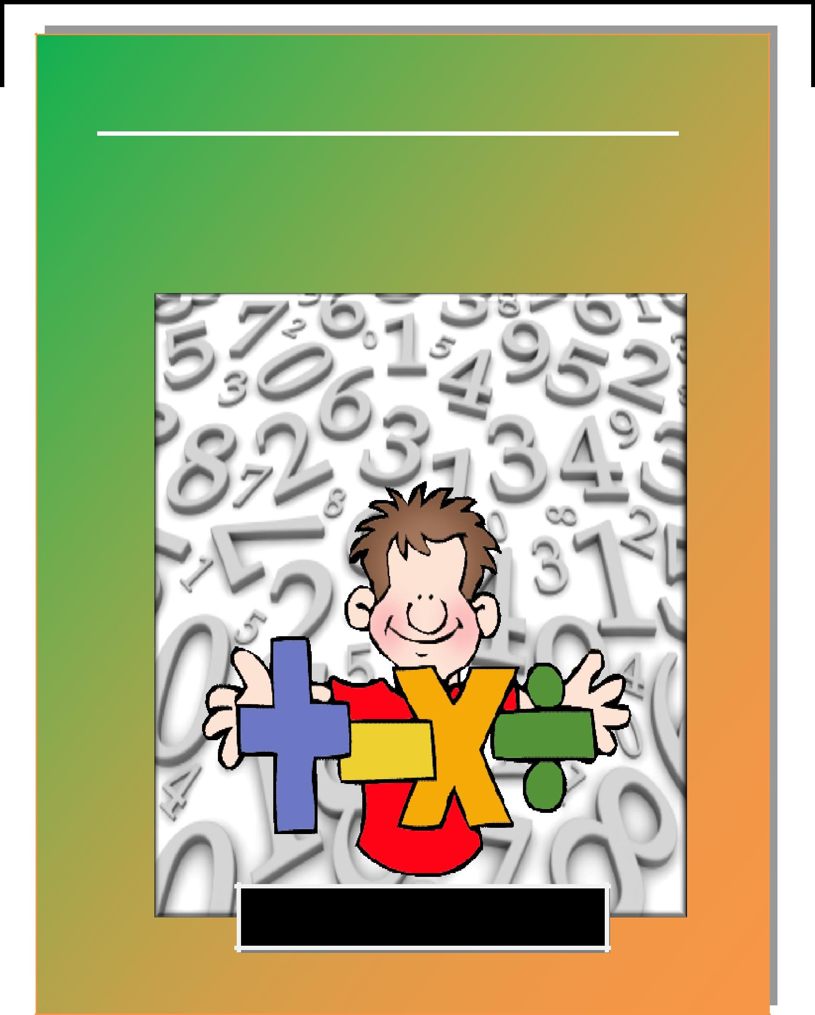

**WORKSHEETS**

CLASS IV

1



**Kendriya Vidyalaya Narela**

MATH-MAGIC

BOOK 4

Worksheets Planned For the Year 2016-17

**INTRODUCTION**

The word mathematics often brings frown on the face of children. They feel jittery to learn with numbers. To erase this perception of mathematics and to make it a joyful learning experience this workbook is brought out. This edition of the workbook is prepared specially to develop interest among children to learn mathematics without the feeling of burden (Generous Joy NCF 2005).

**The following are the highlights of this workbook:**

* Readiness exercises
* Child-centered Activities
* Exercises designed especially for the development of understanding, computation and problem-solving skills.
* Strengthening of the learning process though team/group based activities.

The activities in this book aim to fortify the concepts learnt by the child in class and encourage the child to think laterally by approaching each concept from different perspectives. The exercises have been carefully designed and arranged to enable the child to work them out individually.

I trust this workbook will prove beneficial to students, teachers and parents as well.

**ACKNOWLEDGEMENT**

We thank the Principal, Headmistress and Teachers of K .V. Hebbal for their guidance, support and co-operation. It is their encouragement that made it possible to bring out this workbook to reach out to the children of all the KV’s included in cluster 2.

3

**WORK BOOK IN MATHEMATICS (2016-17)**

**Class 4**

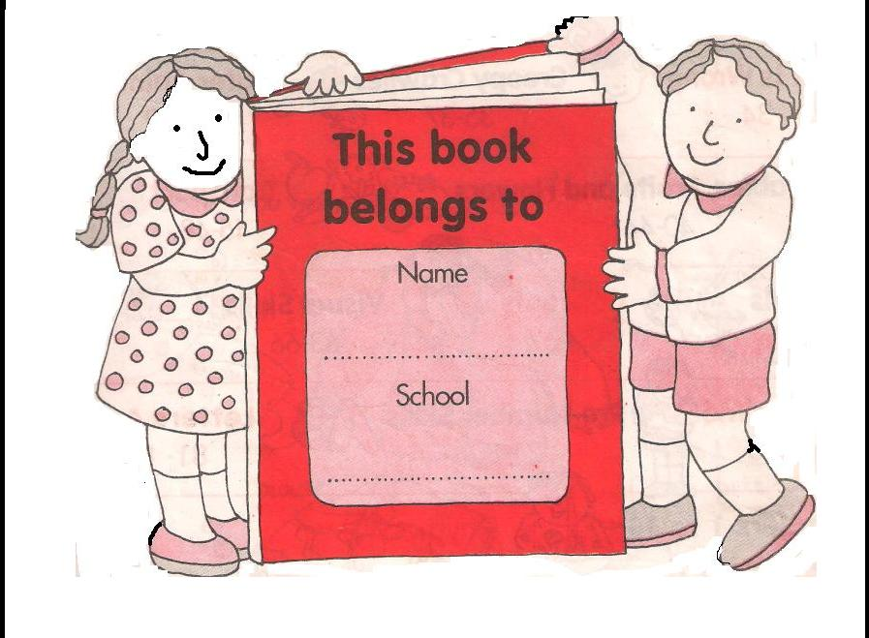

**Paste your photo in the box:**

**TABLE OF CONTENT**

|  |  |  |  |  |  |
| --- | --- | --- | --- | --- | --- |
| **SL.** | **MONTH** | **TOPIC** | **No of** | **PAGE** |  |
| **NO** |  |  | **W.S** |  |  |
|  |  |  |  |  |  |
| **1** | **APRIL-MAY** | **a. BUILDING WITH BRICKS** | **1 TO 4** | **6 – 9** |  |
|  |  | **b. LONG AND SHORT** |  | **10 – 13** |  |
|  |  |  |  |  |  |
| **2** | **JUNE-JULY** | **a. TRIP TO BHOPAL** | **1 TO 4** | **14 – 17** |  |
|  |  | **b. TICK TICK TICK** |  | **18 – 21** |  |
|  |  |  |  |  |  |
| **3** | **AUGUST** | **A. THE WAY THE WORLD** | **1 TO 4** | **22 – 25** |  |
|  |  | **LOOKS** |  |  |  |
|  |  | **b. JUNK SELLER** |  | **26 – 29** |  |
|  |  |  |  |  |
|  |  |  |  |  |  |
| **4** | **SEPTEMBER** | **a. JUGS AND MUGS** | **1 TO 4** | **30 – 33** |  |
|  |  |  |  |  |  |
| **5** | **OCTOBER** | **a. CARTS AND WHEELS** | **1 TO 4** | **34 – 37** |  |
|  |  |  |  |  |  |
| **6** | **NOVEMBER** | **a. HALVES AND QUARTERS** | **1 TO 4** | **38 – 41** |  |
|  |  | **b. PLAY WITH PATTERNS** |  | **42 – 45** |  |
|  |  |  |  |  |  |
| **7** | **DECEMBER** | **a. TABLES AND SHARES** | **1 TO 4** | **46 – 49** |  |
|  |  |  |  |  |  |
| **8** | **JANUARY** | **a. HOW HEAVY AND HOW** | **1 TO 4** | **50 – 53** |  |
|  |  | **LIGHT?** |  |  |  |
|  |  | **b. FIELDS AND FENCES** |  | **54 – 57** |  |
|  |  |  |  |  |
|  |  |  |  |  |  |
| **9** | **FEBRUARY** | **a. SMART CHARTS** | **1 TO 4** | **58 – 61** |  |
|  |  |  |  |  |  |

5

|  |  |
| --- | --- |
| **Topic: Building with Bricks** | Date__________ |
| **WORK SHEET No. 1** | Month__________ |

**Competency :- Formation of Numbers**

**1. Fill in the blanks**.

1. A brick has ______edges.
2. A square has ________ sides.
3. A rectangle has _______faces.
4. A soap has _______faces.
5. A cuboidal box has _________ corners.
6. The number of faces in a brick is equal to ________.
7. A dice has __________ faces.
8. A brick is a _______dimensional object.
9. A triangle has ______sides.
10. A triangle has ______ corners.

**2. Count and write the number of faces you can see in each of the following figures and colour each of the faces using different colours.**

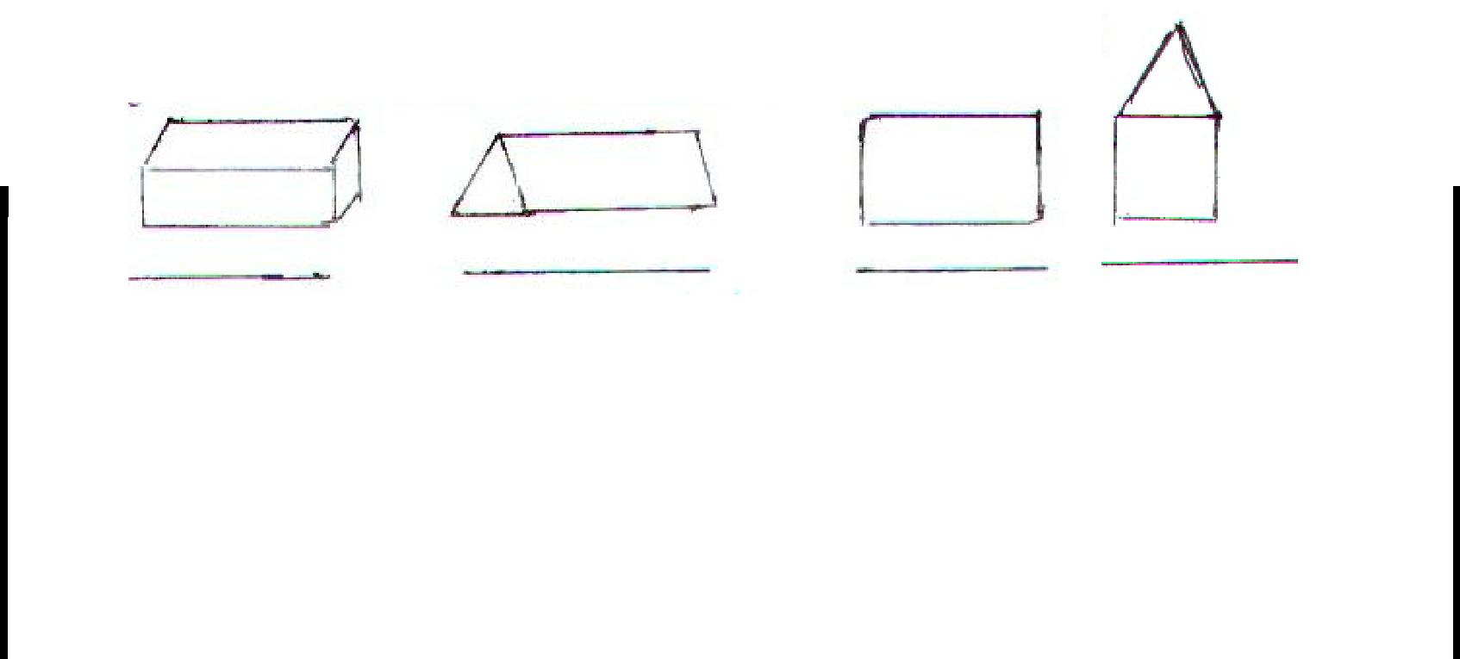

**Teacher’s Signature** **Parent’s Signature**

6

**WORK SHEET NO. 2** Date__________

Month_________

**Competency : Understanding Basic Concepts**

1. **Tick ( ) mark the face of the brick**.

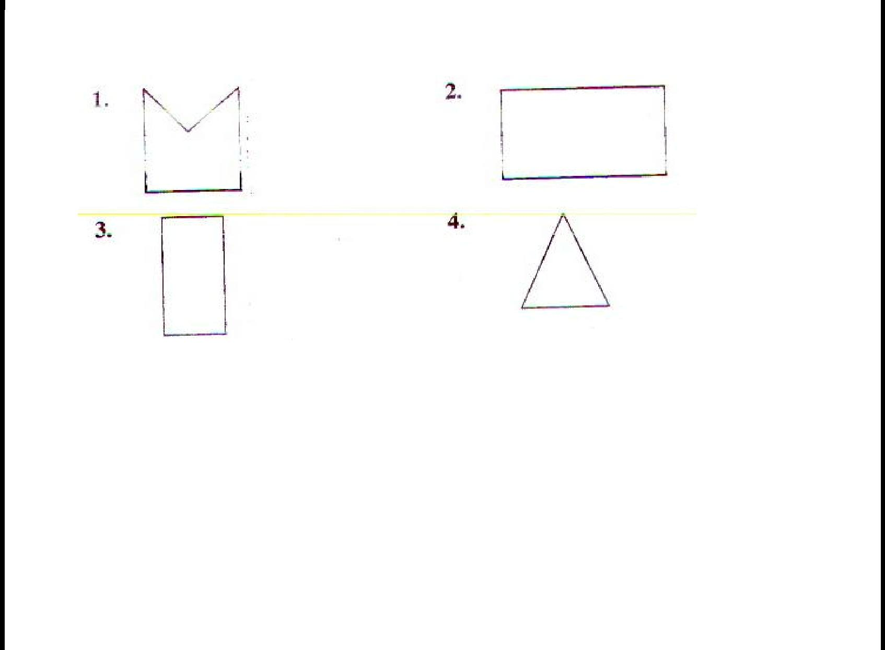

2. O**bserve the following pictures and answer the question below.**

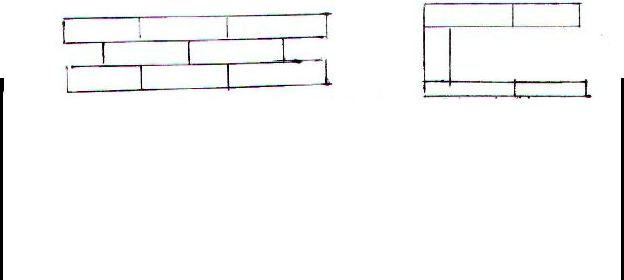

Which wall is stronger and why?

**Teacher’s Signature** **Parent’s Signature**

7

**WORK SHEET NO. 3** Date__________

Month_________

**Competency : Ability to Compute**

1. **Calculate mentally and write the answer.** 
   1. If a brick cost Re 1, then 500 bricks will cost _______________.
   2. If the cost of a brick is Rs 2, then cost of 1000 bricks is Rs ___________
   3. If the cost of 1 brick is Rs 5, then cost of 2000 bricks is Rs______________
   4. If the cost of I brick is Rs 3, then cost of 4000 bricks is Rs______________
   5. If the cost of 1000 bricks is Rs 3000 then the cost of 1 brick is Rs_____________
   6. If the cost of 2000 bricks is Rs 8000, then the cost of 1 brick is Rs_____________
   7. If the cost of 200 bricks is Rs 600, then the cost of 1 brick is Rs_______________
2. **COMPLETE THE TABLE**

|  |  |  |  |  |  |  |
| --- | --- | --- | --- | --- | --- | --- |
|  | Sl.No | Number of | Cost of bricks | Number of | Cost of bricks |  |
|  |  | bricks |  | bricks |  |  |
|  |  |  |  |  |  |  |
|  | 1 | 1,000 | Rs.6,000 | 500 | Rs._________ |  |
|  |  |  |  |  |  |  |
|  |  |  |  |  |  |  |
|  | 2 | 2,000 | Rs.18,000 | 1,000 | Rs._________ |  |
|  |  |  |  |  |  |  |
|  | 3 | 6000 | Rs.24000 | 3000 | Rs._________ |  |
|  |  |  |  |  |  |  |
|  | **Teacher’s Signature** | |  | **Parent’s Signature** | |  |
|  |  |  | 8 |  |  |  |
|  |  |  |  |  |  |  |
|  |  |  |  |  |  |  |

**WORK SHEET NO. 4** Date__________

Month_________

**Competency : Problem Solving Ability**

**1. Make an arch using bricks.**

**2. Draw two wall patterns using bricks.**

**3. Make any two floor patterns using colour paper and stick it below.**

**Teacher’s Signature** **Parent’s Signature**

9

|  |  |
| --- | --- |
| **Topic: Long and Short** | Date__________ |
| **WORK SHEET No. 1** | Month__________ |

**Competency :- Formation of Numbers**

**1. Which is a better unit to measure these? (cm, m or km)**

1. Length of a pin__________
2. Height of a house___________
   1. Distance the scooter travels___________
   2. Length of a park _____________
   3. Length of a pen___________
   4. Height of your pet___________
   5. Length of a 500 rupees note___________
   6. Distance from Bangalore to Rajasthan __________
   7. Thickness of your lunch box __________
3. Height of Qutub Minar ___________
4. Length of your car ____________
5. Distance from school to your house ___________

Tick the longer one?

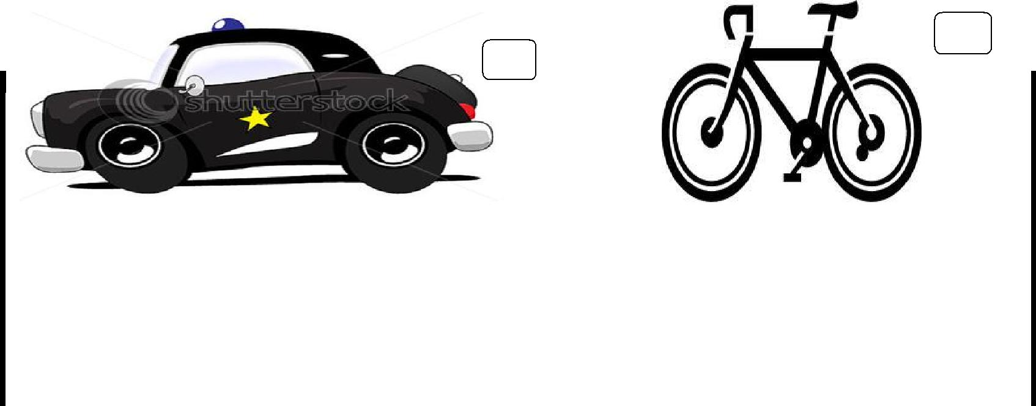

**Teacher’s Signature** **Parent’s Signature**

10

**WORK SHEET NO. 2** Date__________

Month_________

**Competency Problem Solving Ability:**

1**. Find the length of the boundary using a thread. Measure the length in cm** **scale**

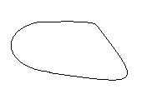

_________cm

2**. Construct line segments of the following length**

a. 4cm b. 2cm

3.A **hare and a tortoise are having a running race.**

Who is near the finishing line? _________________

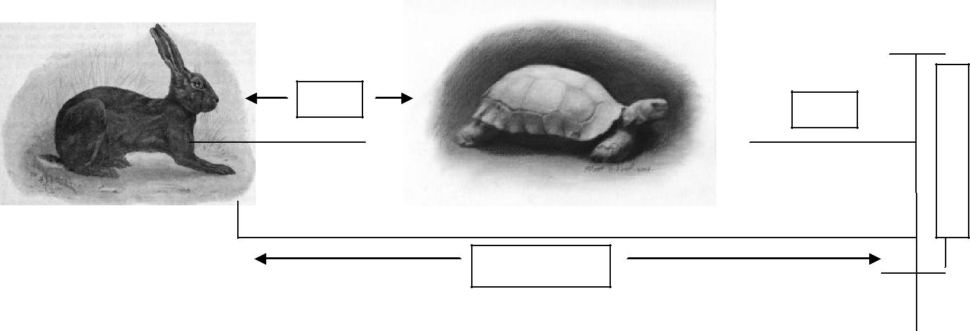

**F**

4 m  3m  **I**



**N**

**I**

**S**

**H**

7 m

________________________________________________________

**Teacher’s Signature** **Parent’s Signature**

11

**WORK SHEET NO. 3** Date__________

Month_________

**Competency : Ability to Compute**

1. **Find the measures** 
   1. 20cm less than 8m 40cm_____________________
   2. 80cm more than 4m 10cm____________________
   3. 15cm less than 6m 75cm______________________
   4. 2m more than 8m 45cm______________________
   5. 7km more than 8km 300m____________________
   6. 600m less than 7km 950m____________________
   7. 9km 200m more than 5km 500m________________
   8. 6m 75cm less than 18m 90cm_________________
2. Draw and colour

An eraser is 15 cm long,

* 1. Draw an eraser 3 cm less than the given measure.
  2. An eraser 6cm longer than the given measurement.

**Teacher’s Signature** **Parent’s Signature**

12

**WORK SHEET NO. 4** Date__________

Month_________

**Competency : Problem Solving Ability**

**A. Complete the table and answer the questions below**

|  |  |  |  |  |
| --- | --- | --- | --- | --- |
| sl.no | name of the plant | last months | this months | cms-grown |
|  |  | height | height |  |
|  |  |  |  |  |
| 1 | TULSI | 5cm | 8cm |  |
|  |  |  |  |  |
| 2 | MANGO | 10cm | 13cm |  |
|  |  |  |  |  |
| 3 | BAMBOO | 20cm | 38cm |  |
|  |  |  |  |  |
| 4 | ROSE | 32cm | 32cm |  |
|  |  |  |  |  |

1. The plant which has grown maximum is________________
2. The plant which has grown minimum is_____________, ____________
3. The plant which has not grown________________
4. The plant which has grown by 18cm is ________________
5. This month _______________ plant is taller than _____________,

_____________

b**. Read the following table and answer the following question**

|  |  |  |
| --- | --- | --- |
| SL.NO | NAMES | DISTANCE OF SIXES BEATENIN A CRICKET MATCH |
|  |  |  |
| 1 | SACHIN | 90m |
|  |  |  |
| 2 | YUVARAJ | 101m 5cm |
|  |  |  |
| 3 | GAMBHIR | 52m 25cm |
|  |  |  |

a. What is the difference between the distance hit by Sachin and Yuvaraj?

**Teacher’s Signature** **Parent’s Signature**

13

|  |  |
| --- | --- |
| **Topic: A Trip to Bhopal** | Date__________ |
| **WORK SHEET No. 1** | Month__________ |

**Competency :- Understanding Basic Concepts:**

**1. Make any six, five- digit numerals using the given digits of numbers.**

Note: digits can be repeated only once.

6,8,5,4

a._______________ b._____________

c._______________ d._____________

e._______________ f.______________

**Competency : Formation of Numbers :**

**1. Use the digits to make greatest and the smallest number**

Note: digits should not be repeated

|  |  |  |
| --- | --- | --- |
| DIGITS | GREATEST NUMBER | SMALLEST NUMBER |
|  |  |  |
| 5,9,0,6,7 |  |  |
|  |  |  |
| 8,3,7,2 |  |  |
|  |  |  |
| 0,9,1 |  |  |
|  |  |  |
| 7,5,1,2,3 |  |  |
|  |  |  |

**2. Fill in the blanks**

1. Smallest and the greatest 2-digit number______________, ______________
2. Smallest and the greatest 5-digit number _____________, ______________
3. Smallest and the greatest 3-digit number _____________, ______________
4. Smallest and the greatest 4-digit number ______________,______________

**Teacher’s Signature** **Parent’s Signature**

14

**WORK SHEET NO. 2** Date__________

Month_________

**Competency : Ability To Compute:**

1. **FILL IN THE BLANKS** :
   1. ______+64979 = 64979
   2. 4256 +______= 4256
   3. 7864 X______=0
   4. 6753 -______=0
   5. 7÷7=______
   6. 0+9537=______
   7. 865 X 1= ______
   8. 2365+5879=________+2365
   9. 6549 ÷______=6549
      1. 0 ÷ 5649=_______
2. **Find the product without multiplying** 
   1. 6250 x 100=________
   2. 958 x 1000=_______
   3. 645978 x10=_______
   4. 78 x 1000=_______
   5. 5654 x 10=_______

**Teacher’s Signature** **Parent’s Signature**

15

**WORK SHEET NO. 3** Date__________

Month_________

**Competency : Ability to Compute**

**A. Perform these operations**

a. Add 2645, 65298 b. Find the sum of 2764+64645

b. Subtract 6986 from 10026 d. Find the difference between

8945 and 65450

**B. Find the product of the following numbers**

a. 65 and 98 b. 12 and 79

**Teacher’s Signature** **Parent’s Signature**

16

**WORK SHEET NO. 4** Date__________

Month_________

**Competency : Problem Solving Ability**

A.



Write numbers which can be

divided by 10, 3, 2 and 5 and  =_______________



comes between 20 and 35

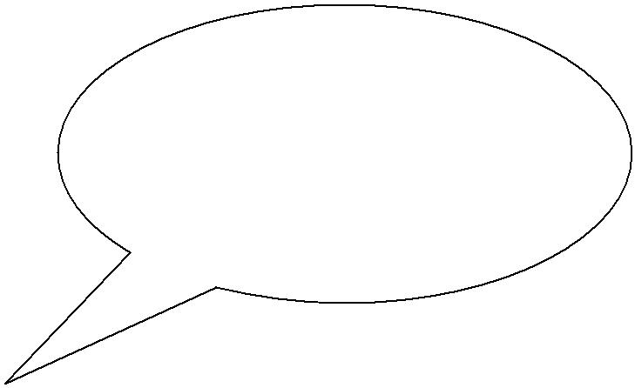

B.

Madam gave 4 toffies each to

40 students of her class she =_______________

has ten toffies left. How many toffies did she have?

C**. Study the table and answer the following question**

|  |  |  |
| --- | --- | --- |
| SL.NO | NAME OF ITEM | COST PER ITEM |
|  |  |  |
| 1 | PIZZA | Rs.50 |
|  |  |  |
| 2 | BURGER | Rs.35 |
|  |  |  |
| 3 | SOFTDRINK | Rs.20 |
|  |  |  |

A.Neeta buys 2 burgers and a pizza she pays Rs.200 how much change does she get back?

**Teacher’s Signature** **Parent’s Signature**

17

|  |  |
| --- | --- |
| **Topic: Tick Tick Tick** | Date__________ |
| **WORK SHEET No. 1** | Month__________ |

**Competency :- Undestanding Basic Concepts:**

1**. Write the following in short form**

* 1. 3rd July 1975 _____________
  2. 25th November 2003 ____________
  3. 1st January 2007 _____________
  4. 13th march 2001 _____________
  5. Your date of birth _____________
  6. Independence day _____________
  7. Republic day ______________
  8. Christmas _______________ (write for current year)
  9. Gandhi jayanthi ___________(write for current year)
  10. New year ______________ (write for current year)

1. **Express the following in am or pm** 
   * 1. 12 noon _________
     2. 12 midnight ________
     3. 4:45 in the evening _________
     4. 8’o clock in the morning ___________

**Teacher’s Signature** **Parent’s Signature**

18

**WORK SHEET NO. 2** Date__________

Month_________

**Competency : Understanding Basic Concepts**

A. Sequence the story according to logic and time using alphabets or numbers

ALICE IN THE WONDERLAND

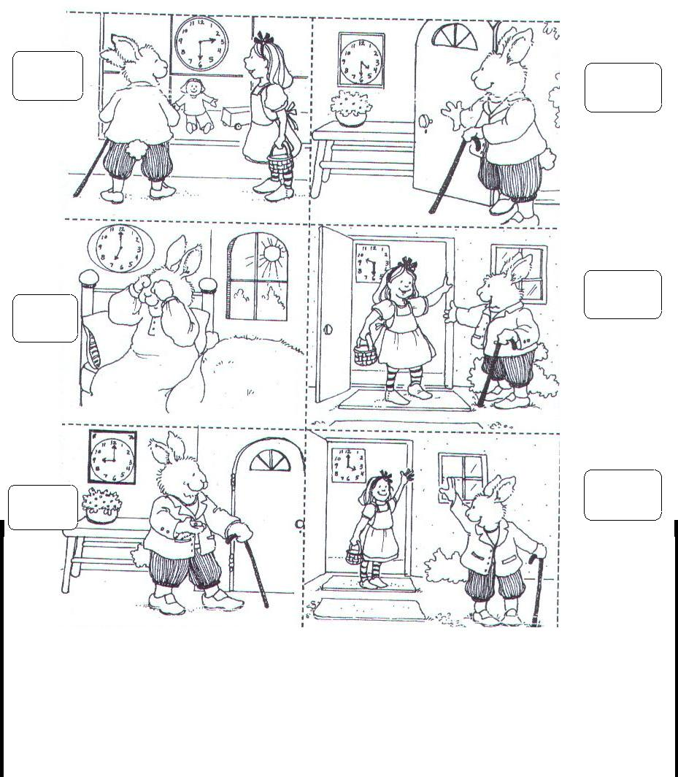

**Teacher’s Signature** **Parent’s Signature**

19

**WORK SHEET NO. 3** Date__________

Month_________

**Competency : Ability to Compute:**

1. **Calculate the number of days** 
   1. Between September 12 and September 23 _________________
   2. Between January 29 and February 5 ___________________
   3. Between March 21 and April 1_________________
   4. Between April 3 and April 10_______________
   5. Between December 16 and December 28 ________________
2. **Change the following to 24 hour clock** 
   1. 2:30 afternoon= ________________
   2. 5:15 morning=_________________
   3. 6:45 evening=_________________
   4. 8:20 night= ________________
   5. 11:10 night=_______________
   6. 9:40 night=_______________
   7. 6:45 morning=____________
   8. 12:00 midnight=_____________

**Teacher’s Signature** **Parent’s Signature**

20

**WORK SHEET NO. 4** Date__________

Month_________

**Competency : Problem Solving Ability**

**A. Rearrange these events in order and draw the time line and answer below**

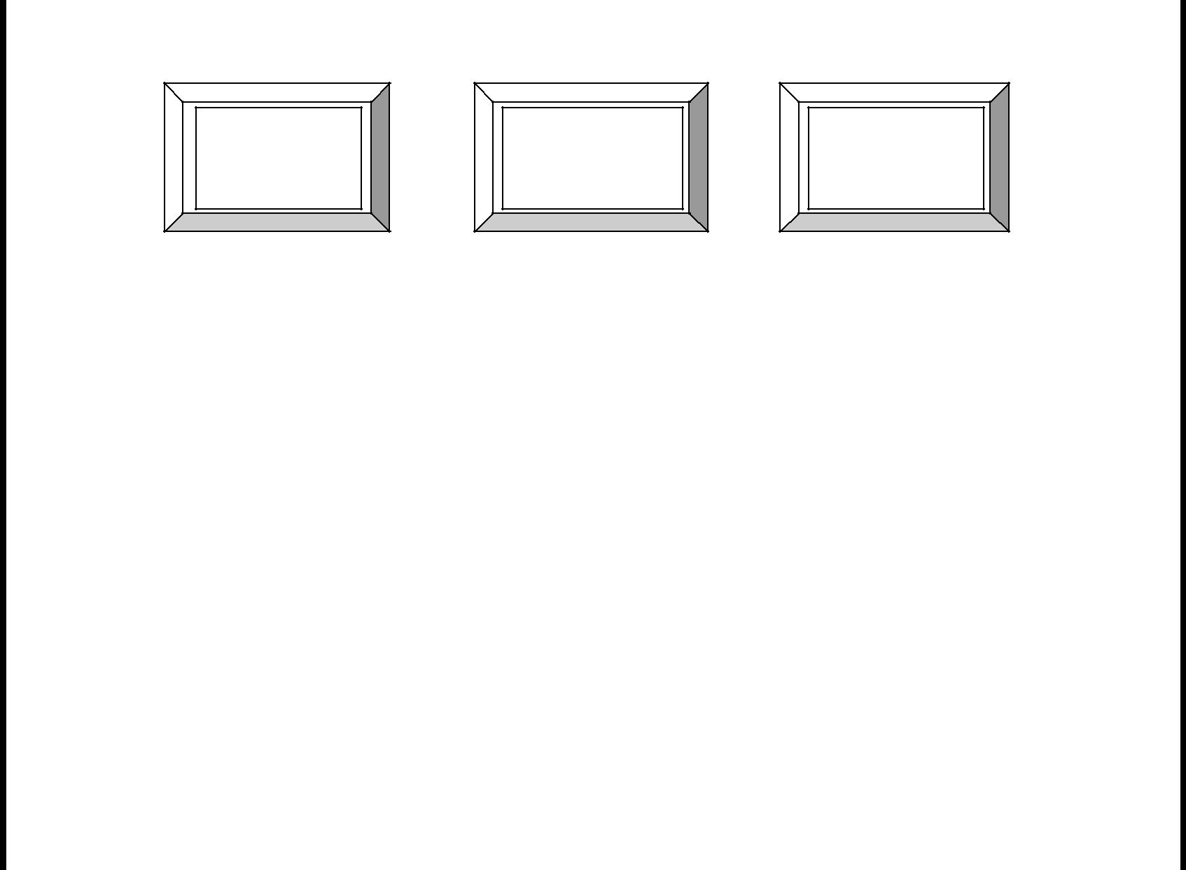

5.3.02

Stood up

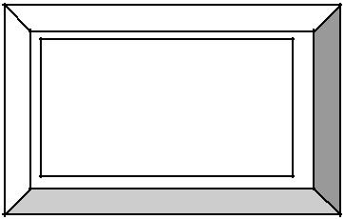

7.6.02

Walked

16.7.01

First tooth

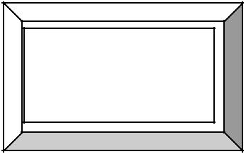

12.7.01

Born

15.2.02

Crawled

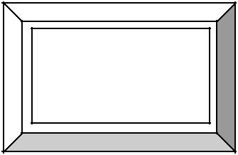

20.11.01

Sat up

How old was Seema?

1. When she walked? ______________
2. When she sat up? ________________
3. When she crawled? ________________

**Teacher’s Signature** **Parent’s Signature**

21

|  |  |
| --- | --- |
| **Topic: The Way the World Looks** | Date__________ |
| **WORK SHEET No. 1** | Month__________ |

**Competency :- Understanding Basic Concepts**

**A. Study the map carefully and answer the following questions**

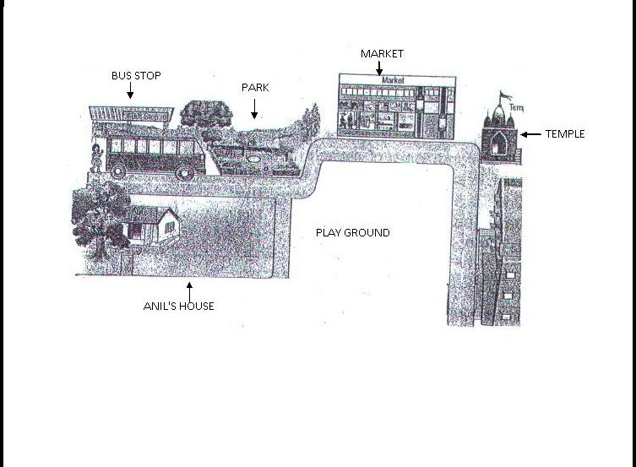

|  |  |  |
| --- | --- | --- |
| **B. Tick ( ) the correct answer:** | |  |
| 1. | What is closer to the temple? |  |
|  | a. School | b. Anil’s house |
| 2. | What is closer to Anil’s house? |  |
|  | a. Bus stop | b. Market |
| 3. | Which is closer to the park? |  |
|  | a. Bus stop | b. park |



**Teacher’s Signature** **Parent’s Signature**

22

**WORK SHEET NO. 2** Date__________

Month_________

**Competency : Understanding Basic Concepts**

**A. Draw lines to match the side view with the top view of the same object**

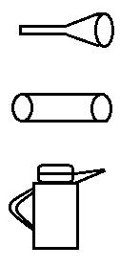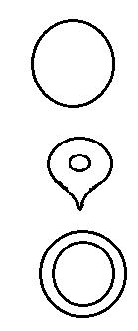

**B. Draw the following**

a. Side view of a bus b. Top view of the teacher’s table c. Front view of a car



**Teacher’s Signature** **Parent’s Signature**

23

**WORK SHEET NO. 3** Date__________

Month_________

**Competency : Problem Solving Ability**

**A. Help kitty to reach his home.**

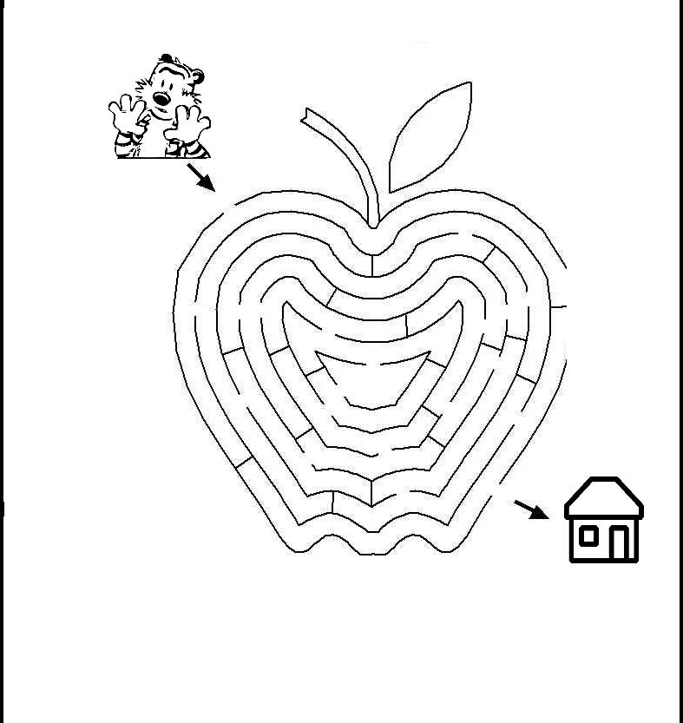

**Teacher’s Signature** **Parent’s Signature**

24

**WORK SHEET NO. 4** Date__________

Month_________

**Competency : Problem Solving Ability**

**A. Help the frog to find the flowers**

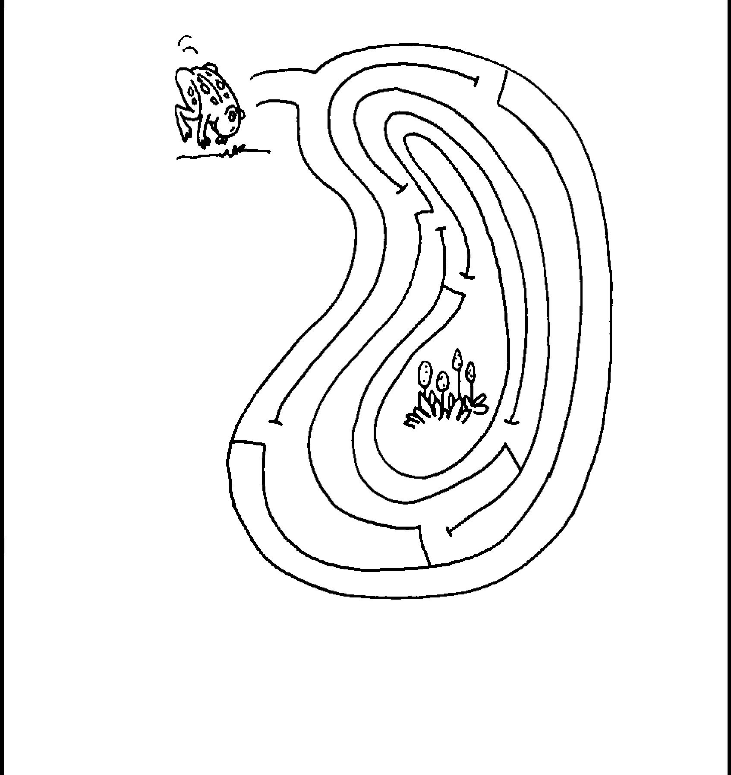

**Teacher’s Signature** **Parent’s Signature**

25

|  |  |
| --- | --- |
| **Topic: The Junk Seller** | Date__________ |
| **WORK SHEET No. 1** | Month__________ |
| **Competency :-Ability to compute** |  |
| **1. Find the value of the following notes:** |  |

* 1. 5notes of Rs 100 =______________
  2. 12 notes of Rs5 =_______________
  3. 10 notes of Rs.10 =______________
  4. 15 notes of Rs.50= ______________
  5. 6 notes of Rs.1000=______________
  6. 8 notes of Rs.20=_________________
  7. 14 notes of Rs.2=_________________

1. **How many?**

a.50 rupees notes are needed to make Rs.200__________________

Rs.800__________________

b. 20 rupees and 10 rupees notes are needed to make Rs.190___________________

Rs.270___________________

c. 1000 rupees notes are needed to make Rs.7000___________________

Rs.10000___________________

d.500 rupees, 100 rupees and 5 rupees notes are needed to make Rs.620___________________

Rs.910___________________

**Teacher’s Signature** **Parent’s Signature**

26

Working space

|  |  |
| --- | --- |
| **WORK SHEET NO. 2** | Date__________ |
|  | Month_________ |
| **Competency : Ability to Compute** |  |
| 1**. Multiply the following by split method:** |  |
| a. 25 x 98 | b. 28 x 75 |

c. 86 x 45 d. 132 x 61

2. **If a person earns Rs.73 a day, find how much he earns in:**

a.7 days=_______________

1. 6 weeks=______________
2. 89 days=_______________

d.17 weeks=______________

**Teacher’s Signature** **Parent’s Signature**

27

**WORK SHEET NO. 3** Date__________

Month_________

**Competency : Ability to Compute 1. Calculate the interest paid:**

|  |  |  |  |  |  |  |  |  |  |  |  |  |  |  |
| --- | --- | --- | --- | --- | --- | --- | --- | --- | --- | --- | --- | --- | --- | --- |
|  |  |  |  |  |  |  |  |  |  |  |  |  |  |  |
|  | SL.NO |  |  | AMOUNT | |  | AMOUNT WITH INTEREST | | | | INTEREST | |  |  |
|  |  |  |  |  |  |  |  |  |  |  |  |  |  |  |
|  | 1 |  |  | Rs. 600 | |  | Rs.680 | |  |  |  |  |  |  |
|  |  |  |  |  |  |  |  |  |  |  |  |  |  |  |
|  | 2 |  |  | Rs.5000 | |  | Rs.5500 | |  |  |  |  |  |  |
|  |  |  |  |  |  |  |  |  |  |  |  |  |  |  |
|  | 3 |  |  | Rs.956 | |  | Rs.1500 | |  |  |  |  |  |  |
|  |  |  |  |  |  |  |  |  |  |  |  |  |  |  |
|  | 4 |  |  | Rs.678 | |  | Rs.1000 | |  |  |  |  |  |  |
|  |  |  |  |  |  |  |  |  |  |  |  |  |  |  |
|  | 5 |  |  | Rs.723 | |  | Rs.850 | |  |  |  |  |  |  |
|  |  |  |  | |  |  |  |  |  |  |  |  |  |  |
| **2. Complete the Table:** | | | | | |  |  |  |  |  |  |  |  |  |
|  |  |  |  |  |  |  | |  | |  | |  | |  |
|  | SL.NO |  |  | ITEM |  | BOUGHT FOR | | SOLD FOR | | PROFIT OR | | BY HOW | |  |
|  |  |  |  |  |  |  |  |  |  | LOSS |  | MUCH? | |  |
|  |  |  | |  |  |  | |  |  |  |  |  |  |  |
|  | 1 | 1 | | Kg Peas |  | Rs.32 | |  | Rs.40 |  |  |  |  |  |
|  |  |  | |  |  |  | |  |  |  |  |  |  |  |
|  | 2 | 2 | | Kg Apples |  | Rs.108 | |  | Rs.119 |  |  |  |  |  |
|  |  |  | | |  |  | |  |  |  |  |  |  |  |
|  | 3 | 10 Pencils | | |  | Rs.36 | |  | Rs.43 |  |  |  |  |  |
|  |  |  | | |  | | |  |  |  |  |  |  |  |
|  | 4 | 30 Note books | | | Rs.125 | | |  | Rs.188 |  |  |  |  |  |
|  |  |  |  |  |  |  |  |  |  |  |  |  |  |  |
|  | 5 | 1 | | Radio |  | Rs.300 | |  | Rs.125 |  |  |  |  |  |
|  |  |  | |  |  |  | |  |  |  |  |  |  |  |
|  | 6 | 1 | | T.V |  | Rs.10,000 | |  | Rs.9999 |  |  |  |  |  |
|  |  |  | | |  |  | |  |  |  |  |  |  |  |
|  | 7 | Table | | |  | Rs.325 | |  | Rs.650 |  |  |  |  |  |
|  |  |  | | |  |  |  |  |  |  |  |  | |  |
| **Teacher’s Signature** | | | | | |  |  |  |  |  | **Parent’s Signature** | | |  |
|  |  |  |  |  |  | 28 | | |  |  |  |  |  |  |
|  |  |  |  |  |  |  |  |  |  |  |  |  |  |  |
|  |  |  |  |  |  |  |  |  |  |  |  |  |  |  |

**WORK SHEET NO. 4** Date__________

Month_________

**Competency : Problem Solving Ability**

**1. SOLVE:**

a. Cost of one potato bun is Rs. 6. Ram bought 5 buns. He gave Rs 50 to the shopkeeper. How much money should he get back?

**2.Read the following table and answer the following questions below**:

|  |  |  |
| --- | --- | --- |
| SL.NO | ITEM | PRICE |
|  |  |  |
| 1 | 5 Erasers | Rs.35 |
|  |  |  |
| 2 | 15 Pencils | Rs.60 |
|  |  |  |
| 3 | 2 Markers | Rs.92 |
|  |  |  |
| 4 | 7 Staplers | Rs.110 |
|  |  |  |
| 5 | 4 Sharpener | Rs.3 |
|  |  |  |

1. 30 erasers cost _________________
2. 8 Staplers cost_________________
3. 9 sharpeners cost________________

**Teacher’s Signature** **Parent’s Signature**

29

|  |  |
| --- | --- |
| **Topic: Jugs and Mugs** | Date__________ |
| **WORK SHEET No. 1** | Month__________ |

**Competency :-Formation of Numbers**

**A. Use the appropriate unit (L or ml) for the following:**

1. Water in a small cup__________
2. Capacity of water in a water tank___________
3. Cough syrup in a spoon____________
4. Oil in an oil tank________
5. Eye drop in an eyedropper__________
6. Water in the sump_________
7. shampoo in sachet_________
8. Milk in a milk packet________

**Competency: Problem Solving Ability**

A. Draw any three standard measuring jars used for measuring the liquid



**Teacher’s Signature** **Parent’s Signature**

30

**WORK SHEET NO. 2** Date__________

Month_________

**Competency : Formation of Numbers**

1. **Complete the following** a. 1 litre =_______ml

b. _______ times 500ml =1litre c._______ times 100ml = 1litre

1. _______ times 200ml = 1 litre
2. _______ times 250ml = 1 litre
3. ¾ of a litre =______ml
4. ¼ of a litre= _______ml
5. ½ of a litre=_______ml

**B. Fill in the blanks**

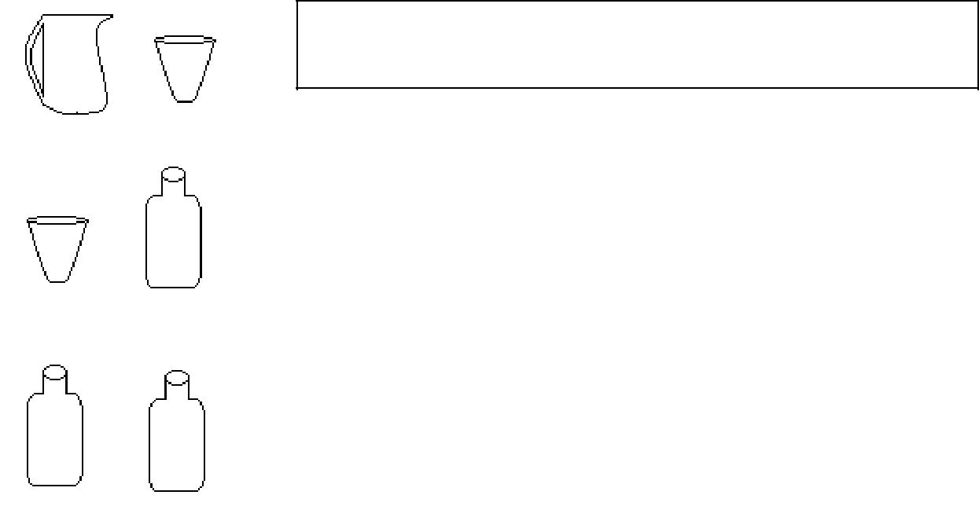

The jar holds __________ water than the glass tumbler (less or more)

The glass tumbler holds _______ water than the bottle (more or less)

Both the bottles hold the __________ quantity of water (same or different)

**Teacher’s Signature** **Parent’s Signature**

31

**WORK SHEET NO. 3** Date__________

Month_________

**Competency : Ability to Compute**

**A. Look at the amount of water in each container. Label it and find the total**

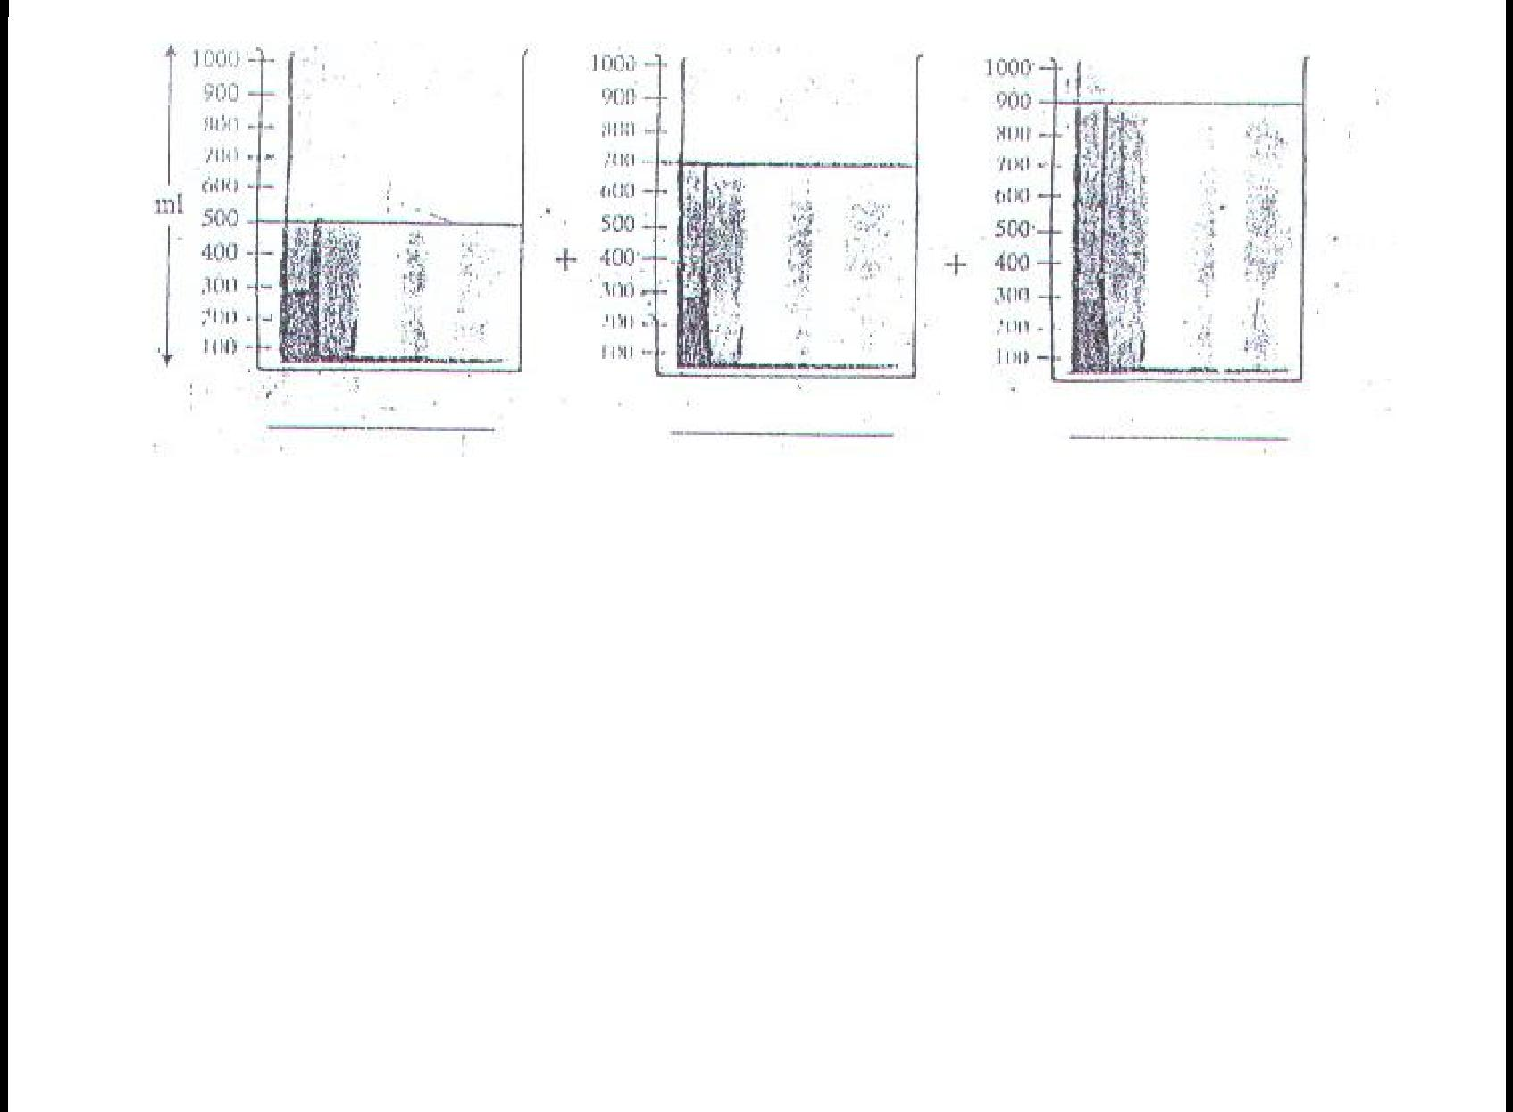

**Answer:__________________________________________________________**

**B. What is the total capacity of the 3 drums?**

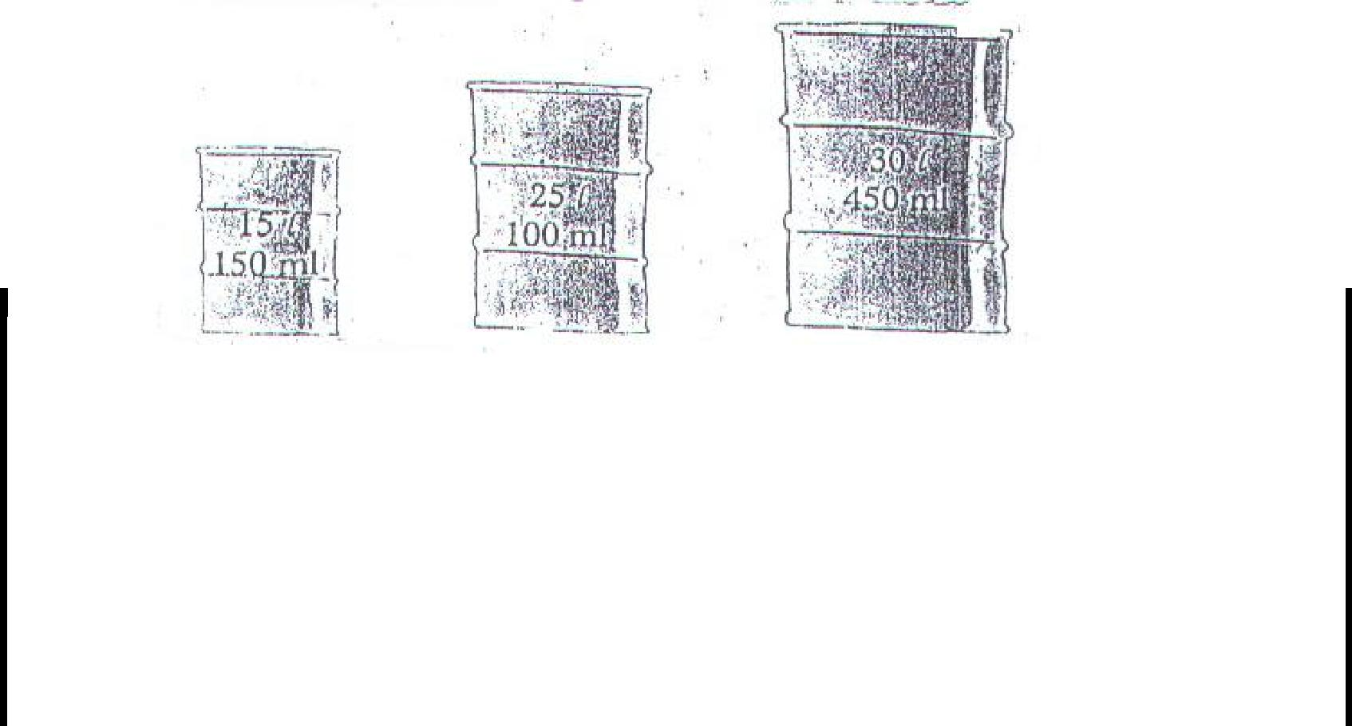

Answer: _____________________________________________________________________

**Teacher’s Signature** **Parent’s Signature**

32

**WORK SHEET NO. 4** Date__________

Month_________

**Competency : Problem Solving Ability**

* 1. **Study the table and Solve**

a. water required by a family for different purposes in a day is as follows

|  |  |
| --- | --- |
| purpose | Amount of water used |
|  |  |
| Washing clothes and utensils | 35 litres |
|  |  |
| bathing | 86 litres |
|  |  |
| cooking | 8litres |
|  |  |
| garden | 3litres |
|  |  |

**B. Find:**

1. The total amount of water used in a day.
2. The total amount of water used in a week.

C . The total amount of water used in a month.

**Teacher’s Signature** **Parent’s Signature**

33

**Topic: Carts and Wheels** Date__________

**WORK SHEET No. 1** Month__________

**Competency :-Understanding Basic Concepts**

1. **Trace circles of different sizes using bangles, coins, bottle caps and such other circular objects. Colour the smallest circle in red and the biggest circle in green.**

**Teacher’s sign.** **Parents’ sign.**

34

**WORK SHEET NO. 2** Date__________

Month_________

**Competency : Formation of Numbers**

**ANSWER THE FOLLOWING:**

1. Observe the surroundings and list any three articles which can be used to draw a circle.

---------------------------- ---------------------------------- ---------------

-----------------

**Competency: Ability to compute**

1. Draw the radius and diameter of the given circles and measure it and find the relationship between radius and diameter

Circle A



Radius ____ Diameter: _____

Circle B

Radius ____ Diameter: _____

Relationship between Radius and Diameter



1. Which is the biggest wheel you have seen?

____________________________________

**Teacher’s sign.** **Parents’ sign.**

35

**WORK SHEET NO. 3** Date__________

Month_________

**Competency : Understanding Basic Concepts**

1. **Fill in the blanks ( Hint: Circumference, diameter, radius, circle)** 
   * 1. A _____________ is a simple closed curve.
     2. _______________ is the line that runs between the circle and its centre.
     3. _______________divides the circle into two equal halves.
     4. _______________is the distance around the circle; it is the length of the circle.
   1. **Name the parts of the circle given below:**

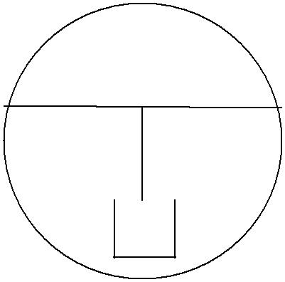

|  |  |  |  |  |  |  |
| --- | --- | --- | --- | --- | --- | --- |
|  |  |  |  |  | O_________________ |  |
|  |  | O | |  | ST________________ |  |
| s |  | T |  |
|  | OC________________ |  |
|  |  |  |  |  |
|  |  |  |  |  |  |
|  |  |  |  |  | OT________________ |  |
|  |  |  |  |  |  |

c

**Competency : Understanding Basic Concepts**

|  |  |  |
| --- | --- | --- |
| **1.** | **Using compass, draw circles of the given radius.** | |
| a) | 3 cm | b) 4 cm |

**Teacher’s sign.** **Parent’s sign.**

36

**WORK SHEET NO. 4** Date__________

Month_________

**Competency : Understanding basic Concepts**

1. **Use a compass to make 2 designs in 2 separate circles.**
2. **Fill in the column:**

|  |  |
| --- | --- |
| RADIUS | DIAMETER |

4 cm

12 cm

6 cm

8 cm

10 cm

2 cm

7 cm

[ Hint: Diameter = 2 X Radius Radius = diameter / 2 ]

1. **Draw a circle with a radius 6 cm. With the same centre draw another circle of radius 4 cm. Within this circle, draw a third circle of radius 2 cm within this circle**.

**Teacher’s sign.** **Parent’s sign.**

37

**Topic: Halves and Quaters** Date__________

**WORK SHEET No. 1** Month__________

**Competency :-Understanding basic Concepts**

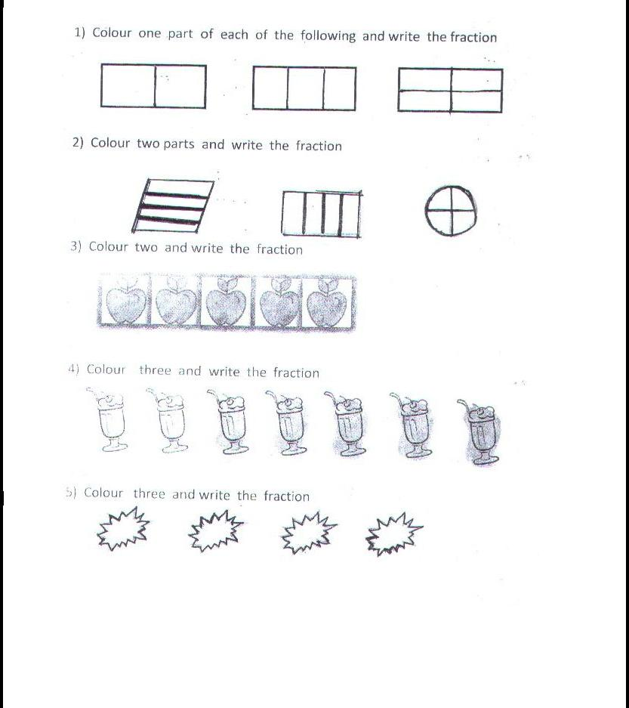

**Teacher’s sign.** **Parents’ sign.**

38

**WORK SHEET NO. 2** Date__________

Month_________

**Competency : Understanding Basic Concepts**

**1. Shade the given figures according to the fractions:**

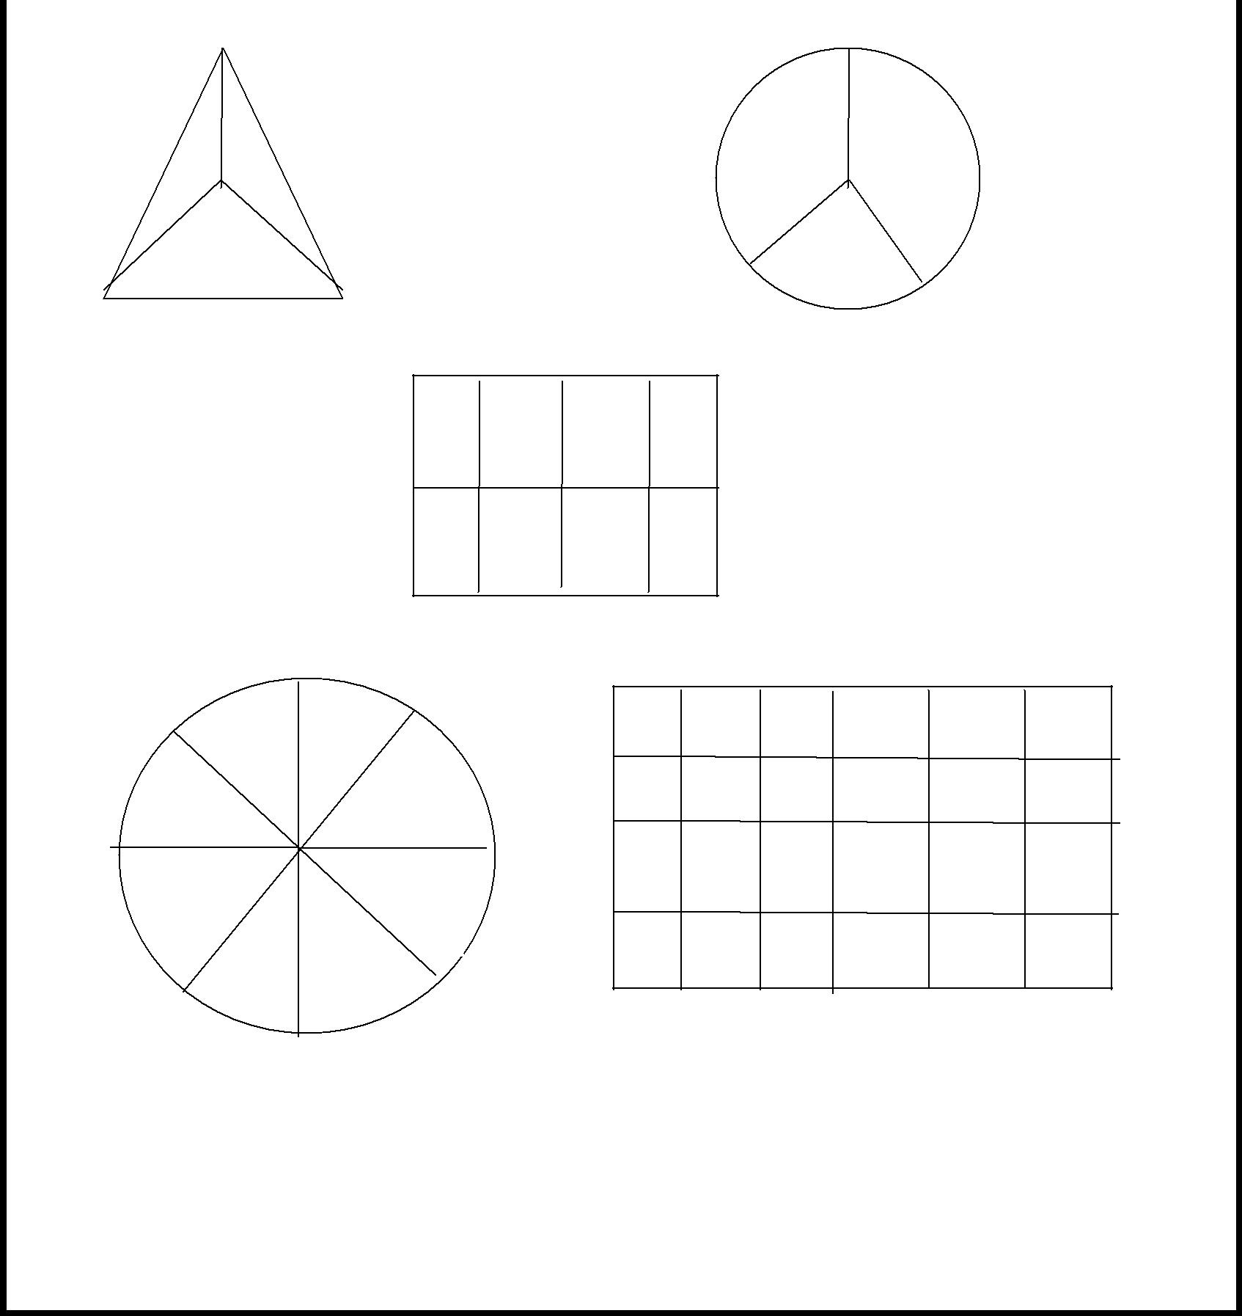

**1 / 3** **2 / 3**

**3/8**

**10/24**

**5/8**

**Teacher’s sign.** **Parents’ sign.**

39

|  |  |  |  |  |  |  |  |  |  |  |  |  |  |  |  |  |  |  |  |  |  |  |  |
| --- | --- | --- | --- | --- | --- | --- | --- | --- | --- | --- | --- | --- | --- | --- | --- | --- | --- | --- | --- | --- | --- | --- | --- |
|  |  |  |  |  |  |  |  |  |  |  |  | **WORK SHEET NO. 3** | | | | | | | |  |  | Date__________ |  |
|  |  |  |  |  |  |  |  |  |  |  |  |  |  |  |  |  |  |  |  |  |  | Month_________ |  |
| **Competency : Formation of Numbers** | | | | | | | | | | | | | | | | | | | |  |  |  |  |
| **1. Fill in the numerals in the boxes:** | | | | | | | | | | | | | | | | | | | |  |  |  |  |
|  | |  |  |  |  |  |  |  |  |  |  |  |  |  |  |  |  |  |  |  |  |  |  |
| e.g In 4/6 | |  |  |  |  |  |  |  |  | is the | | | numerator | and | | 6 | | |  |  | is | the denominator |  |
|  |  | 4 | |  |  |  |  |  |  |  |
|  |  |  |  |  |  |  |  |  |  |  |  |  |  |  |  |  |  |  |  |  |  |
|  |  |  |  |  |  |  |  |  |  |  |  |  |  |  |  |  |  |  |  |  |  |  |  |
| a) | In 3/8 | | |  |  |  |  |  |  | is the | | | numerator | and | | | |  | |  | is | the denominator |  |
|  |  |  |  |  |  |  |  |  |  |
|  |  |  |  |  |  |  | |  |  |
|  |  | |  |  |  |  |  |  |  |  |  |  | | |  | |  |  | |  |  |  |  |
|  |  |  |  |  |  |  |  |  |  |  |  |  |  |  |  |  |  |  |  |  |  |  |  |
|  |  | |  |  |  |  |  |  |  |  |  |  | | |  | |  | | |  |  |  |  |
| b) | In 6/9 , | | |  |  |  |  |  |  |  | is the numerator and | | | | | | |  | |  | is | the denominator |  |
|  |  | |  |  |  |  |  |  |  |  |  |  |  |  |  | |  |  | |  |  |  |  |
|  |  | |  |  |  |  |  |  |  |  | |  |  |  |  | |  |  | |  |  |  |  |
|  |  | |  |  |  |  |  |  |  |  | |  |  |  |  | |  | | |  |  |  |  |
| c) | In 7/8 | |  |  |  |  |  |  |  | is the | | | numerator | and |  | |  | |  |  | is | the denominator |  |
|  |  | |  |  |  |  |  |  |  |  | |  |  |  |  | |  | |  |  | | |  |
|  |  | | |  |  |  |  |  |  |  | |  |  |  |  | |  | |  |  | | |  |
|  |  | | |  |  |  |  |  |  |  | |  |  |  | | |  | | |  | | |  |
| d) | In 8/9 | |  |  |  |  |  |  |  | is the | | | numerator | and | | |  | | | is the denominator | | |  |
|  |  |  |  |  |  |  |  | | |  |
|  |  | |  |  |  |  |  |  |  |  | |  |  |  | | |  | | |  |  |  |  |
|  |  | | |  |  |  |  |  |  |  | |  |  |  | | |  | | |  |  |  |  |
|  |  | | |  |  |  |  |  |  |  | |  |  |  | | | | | |  |  |  |  |
| e) | In 3/5 |  | |  |  |  |  |  |  | is the | | | numerator | and | | |  | | |  | is | the denominator |  |
|  |  |  | | | | | |  | |  |  |  | |  | | |  | | |  |  |  |  |
|  |  | | | | | | | | |  |  |  | |  | | | | | |  |  |  |  |
| f) | In 2/6 is the | | | | | | | | |  |  | numerator | | and |  | | | |  |  | is | the denominator |  |
|  |  |  |  |  |  |  |  |  |  |  |  |  |  |  |  |  |  |  |  |  |  |  |  |
|  |  |  |  |  |  |  |  |  |  |  |  |  |  |  |  |  |  |  |  |  |  |  |  |

**2. Write the fractional numbers ,whose Numerator and Denominators are:**

|  |  |  |  |  |  |  |  |  |
| --- | --- | --- | --- | --- | --- | --- | --- | --- |
| e.g N= 4 ; D = 6 | | 4 |  | N=7 ; D = 5 = | |  |  |  |
|  |  |  |  |  |  |  |  |
|  |  | 6 |  |  |  |  |  |  |
|  |  |  |  |  |  |  |  |
|  |  |  |  |  |  |  |  |  |
|  | |  |  |  |  |  |  |  |
| 1.N= 6 , D= 8 = |  |  |  | N= 8 ; D= 9 |  | |  |  |
|  |  |  |  |  |  |  |  |  |
|  |  |  |  |  |  |  |  |  |

**Teacher’s sign.** **Parents’ sign**

40

|  |  |  |
| --- | --- | --- |
| **WORK SHEET NO. 4** | | Date__________ |
|  |  | Month_________ |
| **Competency : Formation of Numbers** |  |  |
| **1. Fill in the blanks:** |  |  |
| (a) I/2 of litre = _________ml | (b) ¾ of kilo gram = _______ gm | |
| ( c ) 1/4 of a litre= ________ ml | (d) ¾ of litre = | __________ ml |

**2. Show the following fraction in one whole and in collection:**

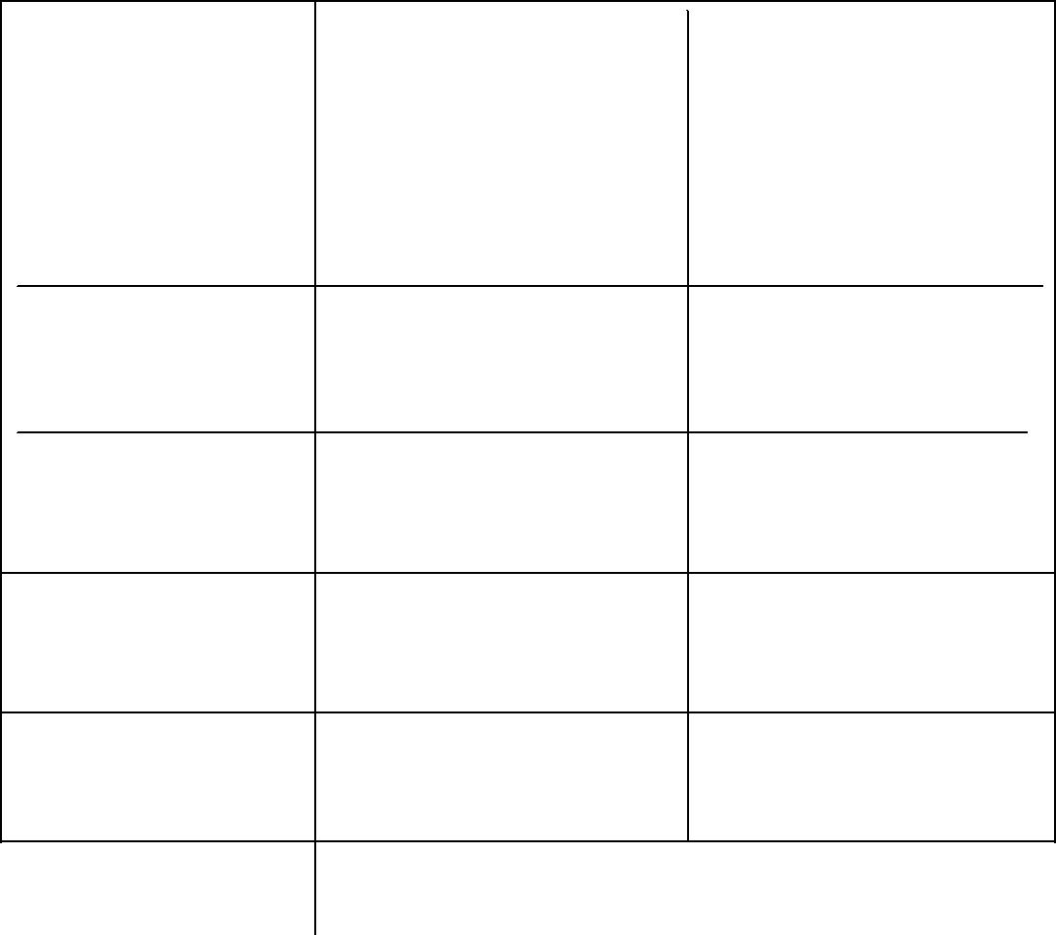

|  |  |  |
| --- | --- | --- |
| Fraction | whole | Collection |
|  |  |  |
| 1 / 4 |  |  |

2 / 4

3 / 4

3/ 5

2 / 8

**Teacher’s sign.** **Parents’ sign.**

41

**Topic: Patterns and Designs** Date__________

**WORK SHEET No. 1** Month__________

**Competency :-Understanding basic Concepts**

**1. Observe the number pattern and extend:**

a) 2462, 2464, 2468 , ________, __________ , ________

1. 7353, 7358, 7363, ____________, ___________, _________
2. 3726, 3763, 3746, ________, ____________, __________
3. 4111, 5111, 6111, ____________, __________, __________
4. 6250, 6300, 6350, __________, __________, ___________
5. 4510, 4514, 4518, ___________, ___________, __________

|  |  |  |  |  |
| --- | --- | --- | --- | --- |
| g) | 2345, 2346, 2347, | __________, | ___________, | ___________ |
| h) | 9323, 9322, 9321, | ___________, __________, | | ____________ |
| i) | 5214, 5224, 5234, | __________, | ___________, | ____________ |

* 1. 1946, 1951, 1956 , _________, __________, ____________

1. **Observe the pattern and extend:**

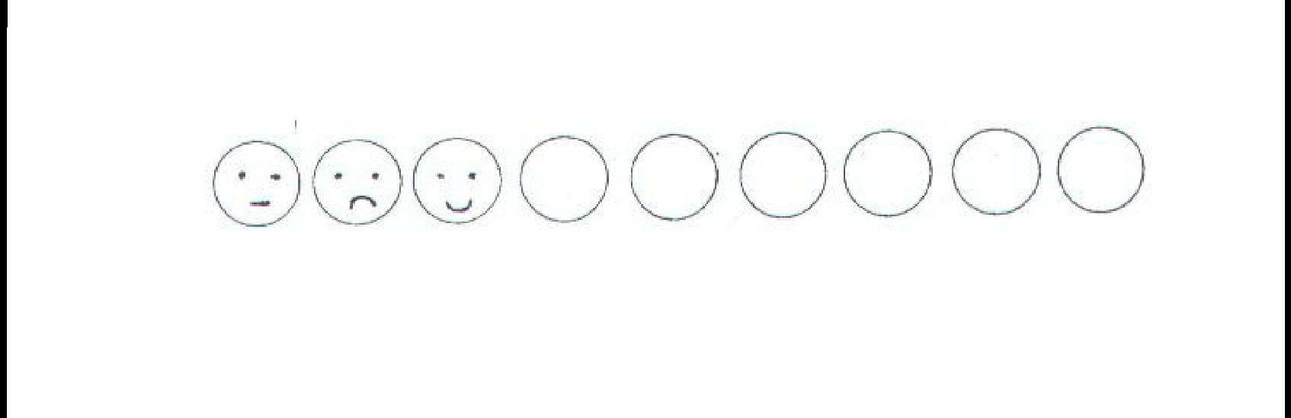

**Teacher’s sign.** **Parents’ sign**

42

**WORK SHEET NO. 2** Date__________

Month_________

**Competency : Understanding Basic Concepts**

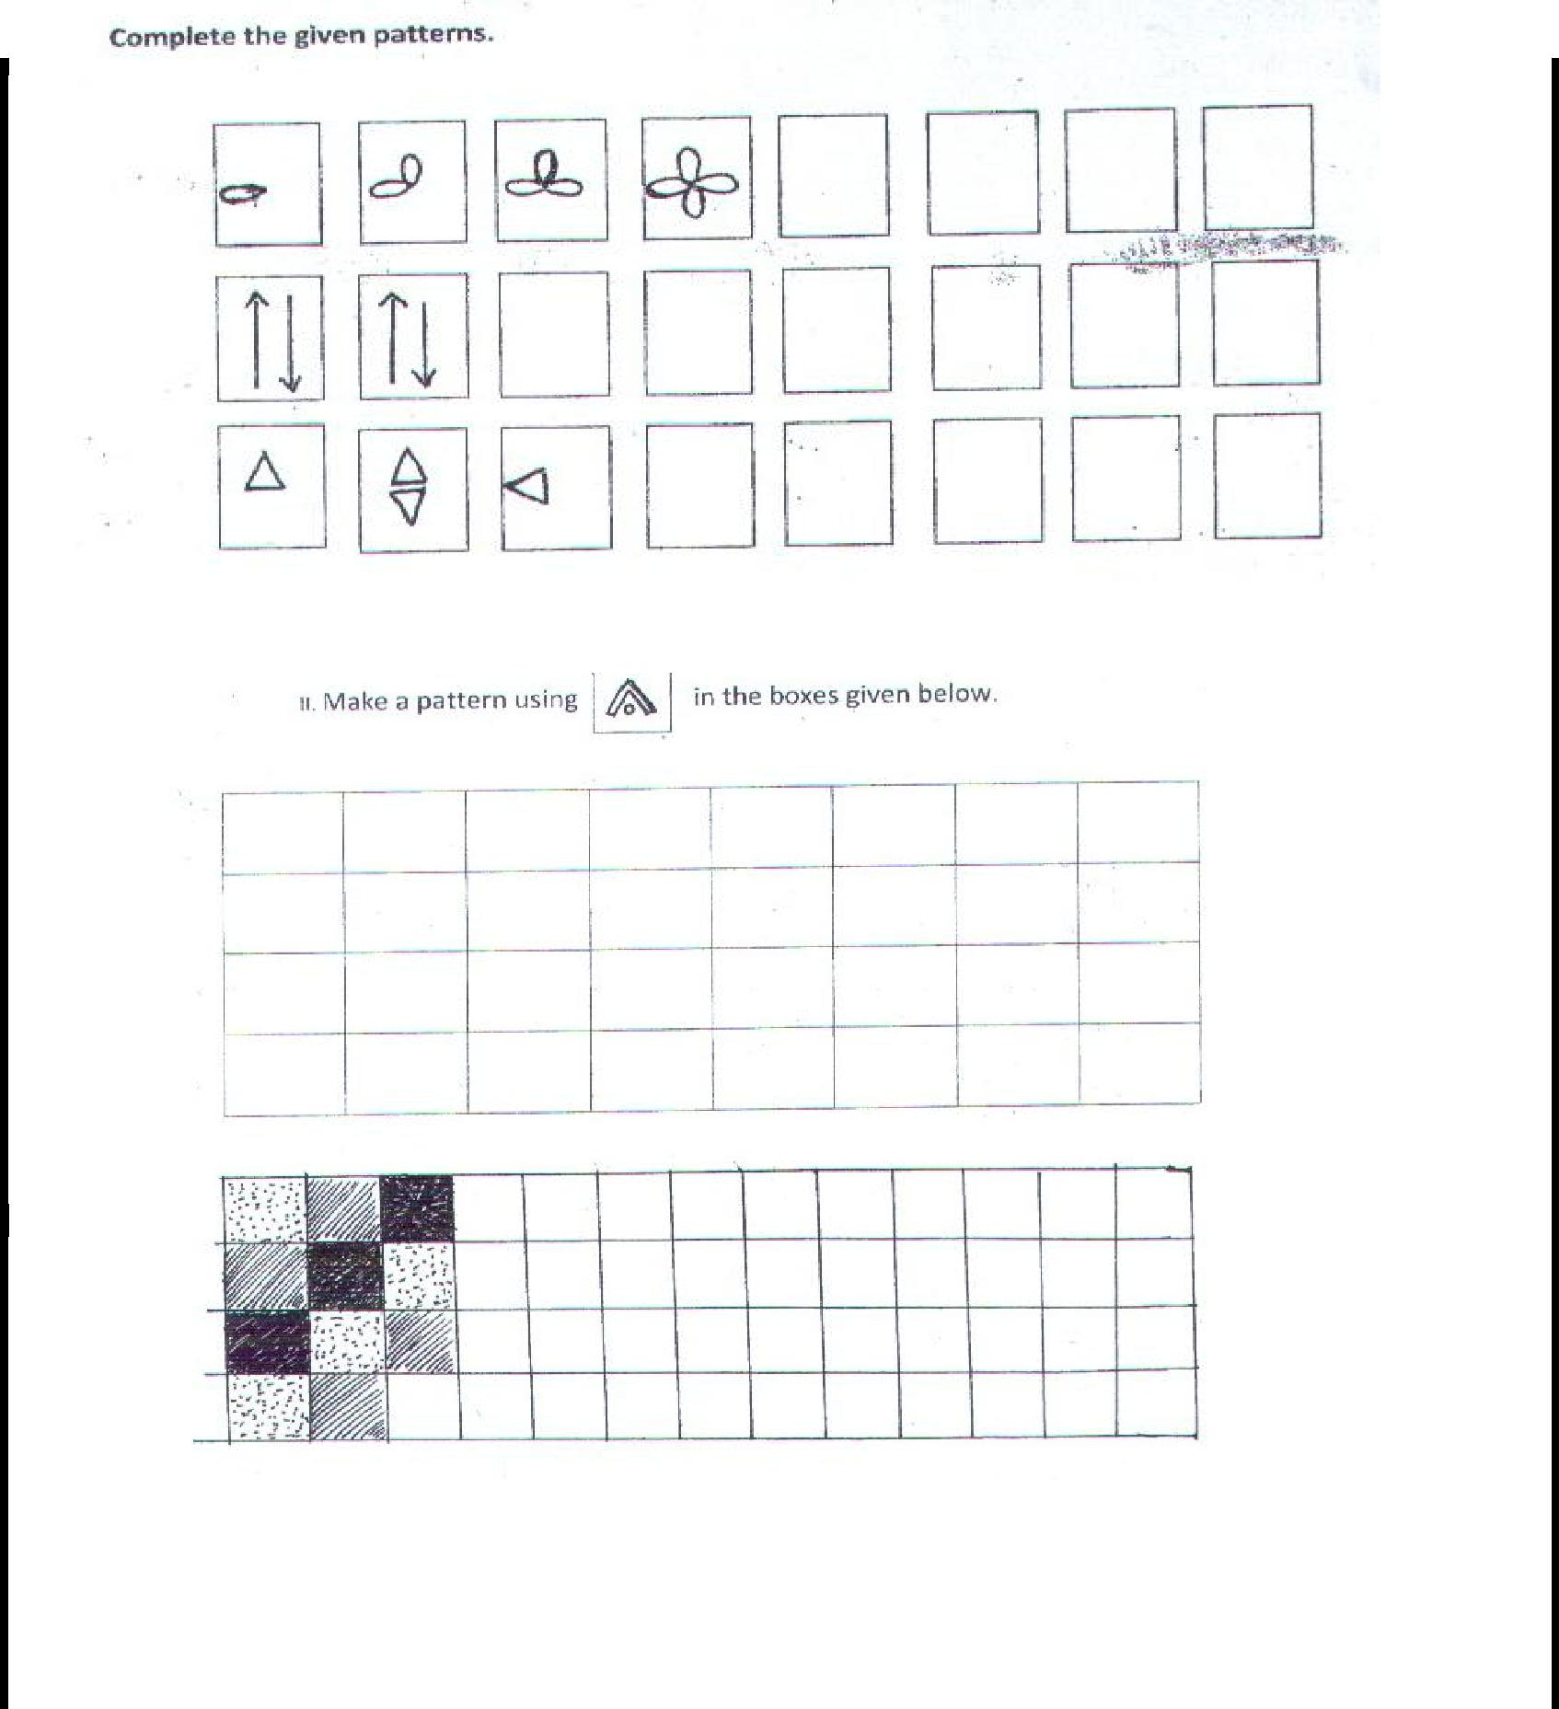

**Teacher’s sign.** **Parents’ sign.**

43

**WORK SHEET NO. 3** Date__________

Month_________

**Competency : Understanding basic Concepts**

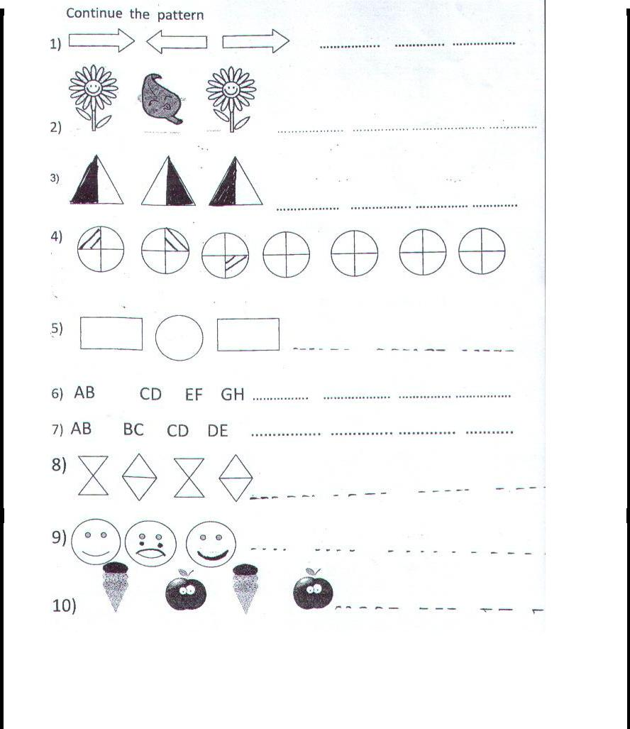

**Teacher’s Sign** **Parent’s Sign**

44

**WORK SHEET NO. 4** Date__________

Month_________

**Competency :Understanding basic Concepts**

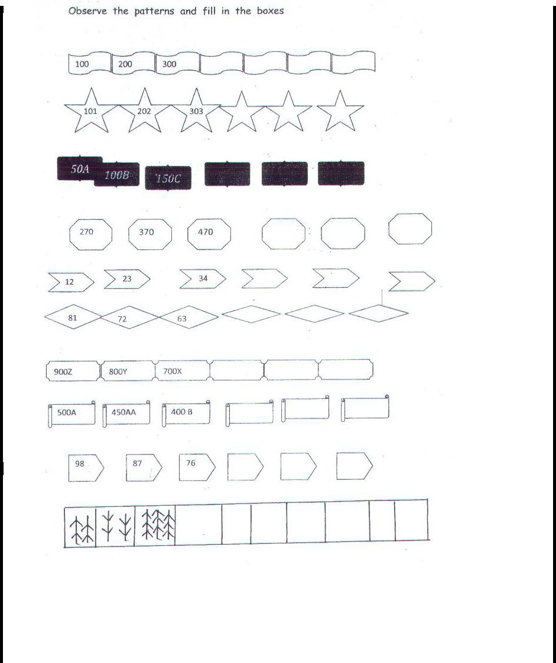

**Teacher’s Sign** **Parent’s Sign**

45

**Topic: Tables and Shares** Date__________

**WORK SHEET No. 1** Month__________

**Competency :-Understandng Basic Concepts**

**1. Write the arrangements of these objects in row and columns (multiplication facts)**

a) b) c)

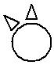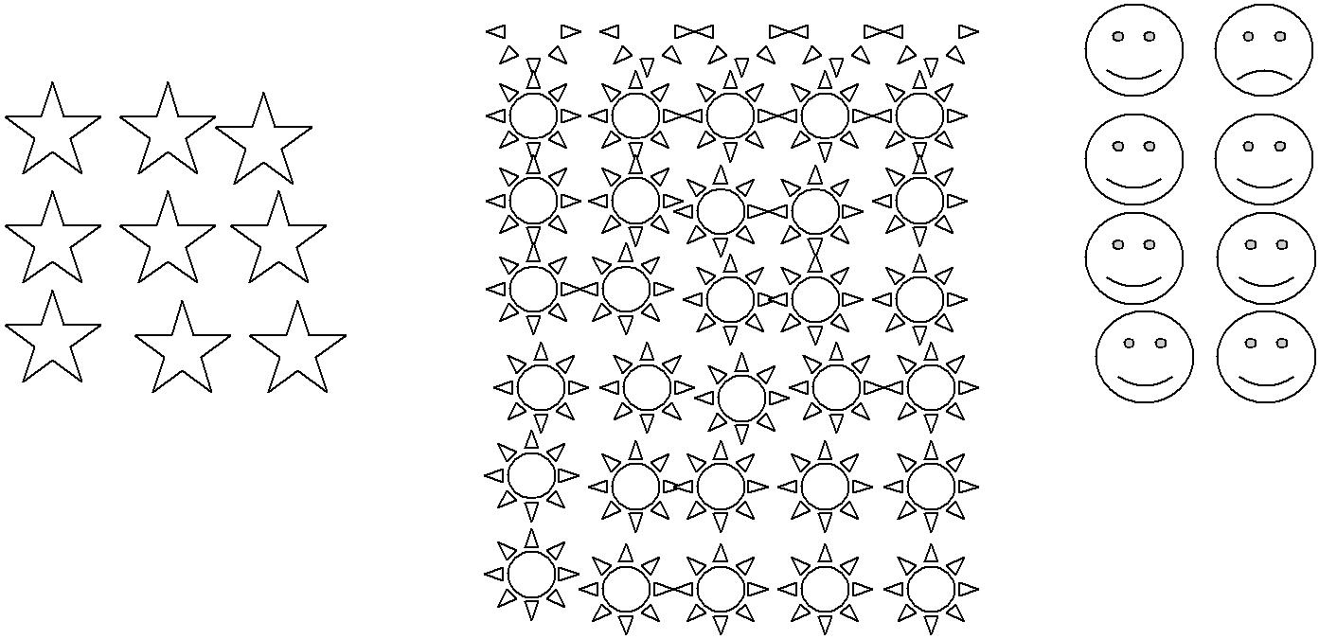

**2. Arrange in three different ways in rows and columns:**

1. 15 boys
2. 28 balls

**Teacher’s sign.** **Parents’ sign.**

46

**WORK SHEET NO. 2** Date__________

Month_________

**Competency : Ability to Compute**

**1. Write these in repeated addition form**

a) 10 x 1 = b) 3 x 2=

c) 6 x 5 = d) 2 x 3=

**2. Make the multiplication table of 13 using any two multiplication tables:**



Table of -



Table of **-**



Table of 13 -

|  |  |  |  |
| --- | --- | --- | --- |
| **3.** | **Find the product of** | |  |
| a) 2 | | x 5 = | b) 12 x 0 = |
| c) 7 | | x 8 = | d) 18 x 50 = |
| e) 17 x 1 = | | | f) 90 x 10 = |
| **4.** | **Find the product of** | |  |
|  | a) 65 x 35 | | b) 102 x 84 |

**Teacher’s sign.** **Parents’ sign.**

47

**WORK SHEET NO. 3** Date__________

Month_________

**Competency : Problem Solving Ability**

1. **Meera plants 50saplings in 10 rows. How many saplings are there in each row?**
2. **You have to distribute 96 oranges equally in 3 baskets. How many oranges will there be in each basket?**
3. **Frame your question:** 
   1. There are 10 packets of sugar. Arun paid 100 rupees for all the packets.

Question:

**d) Try solve these:**

( Division is repeated subtraction)

1. Raju collects 112 sea shells to make necklaces for his sisters. He requires 28 ses shells to make a necklace. How many necklaces did he make?
2. Gangu made sweets for Diwali. He had 80 laddoos. He packs 4 laddoos in each small packet.
   1. How many packets did he make? ------------
   2. If he packs, 20 laddoos in bigger packets how many packets does he get?

**Teacher’s sign.** **Parents’ sign.**

48

**WORK SHEET NO. 4** Date__________

Month_________

**Competency : Ability to Compute**

|  |  |  |
| --- | --- | --- |
| **1. Divide** |  |  |
| a) 28 / 4 = | b) 14/ 2 = | c) 36/ 9 = |
| d) 25 /5 = | e) 100/ 10 = | f) 27/3= |
| g) 44/4= | h) 54/6 = | i) 64/ 8= |

2.**Anu wants change for Rs.100**

How many notes will she get if she wants change?

1. All 50 rupee notes? ___________
2. All 10 rupee notes ? ______________
3. All 20 rupee notes? _______________
4. All 5 rupee notes ? _________________

**3) Divide and find the quotient:**

a) 65 / 5 = b) 108/9 = c) 428 / 2

**Teacher’s sign.** **Parents’ sign.**

49

**Topic: How Heavy? How Light?** Date__________

**WORK SHEET No. 1** Month__________

**Competency :-Understanding Basic Concepts**

1. **Tick the one which has more weight.**

|  |  |  |  |  |
| --- | --- | --- | --- | --- |
| a) | Elephant / Dog | c) | Table / School Bag | |
| b) | Book / Pencil |  | d) | Scale / Chair |

1. **Which pan will go down show by drawing an arrow.**

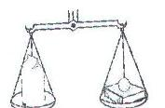

Loaf of bread book

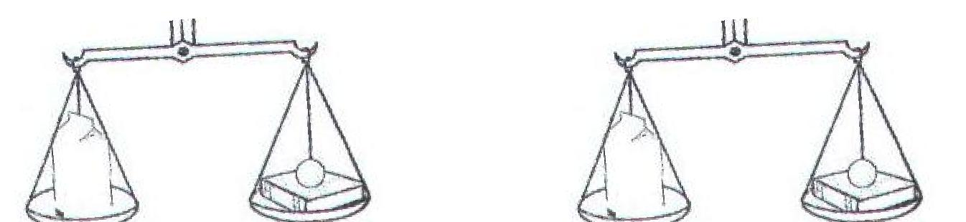

|  |  |  |  |
| --- | --- | --- | --- |
| 250gm | 125gm | 245gm | 270gm |
| 310gm | 360gm | 430 gm | 315gm |

**Teacher’s sign.** **Parents’ sign.**

50

**WORK SHEET NO. 2** Date__________

Month_________

**Competency : Formation of Numbers**

**1. Name 5 things that we usually buy**

in grams in kilograms

1)

2)

3)

4)

5)

1. **Fill in the Blanks**
2. One kilogram = ___________ grams.
3. Half a kilogram = ___________ grams.
4. The heavier one among 100g and 10 kg is ____________
5. 1 kg = 5 x _________ grams.
6. 5 kg = ________ grams.
7. 2 kg = ________ grams.
8. 3 kg = ________ grams.
9. 7 kg = ________ grams.
10. 9 kg = ________ grams.

**Teacher’s sign.** **Parents’ sign.**

51

**WORK SHEET NO. 3** Date__________

Month_________

**Competency : Understanding Basic Concepts**

1. **Fill in kilograms or grams:** 
   1. My friend weighs 25
   2. A sack of wheat weighs 50
   3. A packet of potato chips weighs 50
   4. A tube of fevistick weighs 100
   5. A sack of rice weighs 30
2. **You are given the following weights. Using these weights you have to weigh out different amount of certain items. Which weights will you use?**

|  |  |  |  |  |
| --- | --- | --- | --- | --- |
| Amount to be 1 kg | 500g | 200g | 100g | 50g |
| Weighed |  |  |  |  |
| 1 kg 750 g |  |  |  |  |
| 2 kg |  |  |  |  |
| 900g |  |  |  |  |
| 3 kg 300 g |  |  |  |  |
| 150g |  |  |  |  |
| 1 kg 50 g |  |  |  |  |
| **Teacher’s sign.** |  |  | **Parents’ sign.** |  |
|  | 52 |  |  |  |
|  |  |  |  |  |
|  |  |  |  |  |

**WORK SHEET NO. 4** Date__________

Month_________

**Competency : Ability to Compute**

1. **Add the following in columns:**

a) 13 kg 750g and 24 kg 500 g b) 5 kg 5g and 7kg 17g

c) 2kg 200g, 4kg 600g, 1kg d) 4 kg, 10kg, 200g

1. **Write in columns and subtract:**

a) 38kg 500g from 45kg 250g b) 79kg 759g from 91kg 60g

**Competency: Problem solving ability**

1. **Solve these:** 
   1. A vegetable - seller had 25kg of onions. He sold 20kg 250g. How much onions are left with him?
   2. Mrs. Kapoor has 2KG OF NEEM POWDER. She wants to put it into smaller packets of 200g each. How many packets will she get?

**Teacher’s sign.** **Parents’ sign**.

53

|  |  |
| --- | --- |
| **Topic: Fields and Fences** | Date__________ |
| **WORK SHEET No. 1** | Month__________ |
| **Competency :-Ability to Compute** |  |

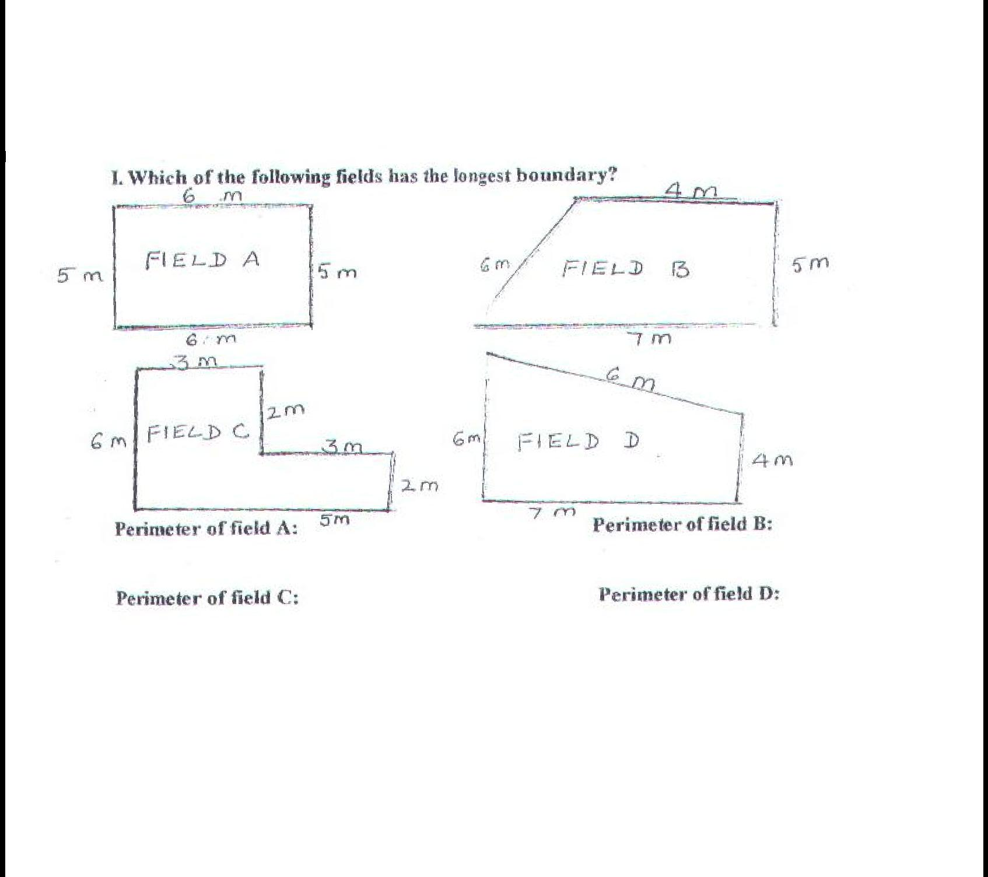

**If the cost of fencing is Rs 25 per meter.How much does it cost to fence the fields?**

Cost of fencing field A : Cost of fencing field B :

Cost of fencing field C : Cost of fencing field D :

**Teacher’s sign.** **Parents’ sign**

54

**WORK SHEET NO. 2** Date__________

Month_________

**Competency : Ability to Compute**

|  |  |  |  |
| --- | --- | --- | --- |
| **I.** | **Find the perimeter** | **of the following** | **, squares , whose sides** |
|  | **measuring** |  |  |
|  | A) 5 cm | b. 7 cm | c) 10 m |

**a) Find the perimeter of rectangle whose length and breadth are given.**

(i) Length = 7 cm breadth = 5 cm

(ii) Length = 12 cm breadth = 8 cm

(iii) Length = 15 cm breadth = 10 cm

**Teacher’s sign.** **Parents’ sign**.

55

|  |  |  |  |
| --- | --- | --- | --- |
|  | **WORK SHEET NO. 3** | Date__________ | |
|  |  | Month_________ | |
| **Competency : Ability to Compute** | |  |  |
| **1. Find the boundary for the following figures:** | |  |  |
| 4 cm | 5 cm | 2m | |
|  |  |  |  |
|  |  |  |  |
|  |  |  |  |

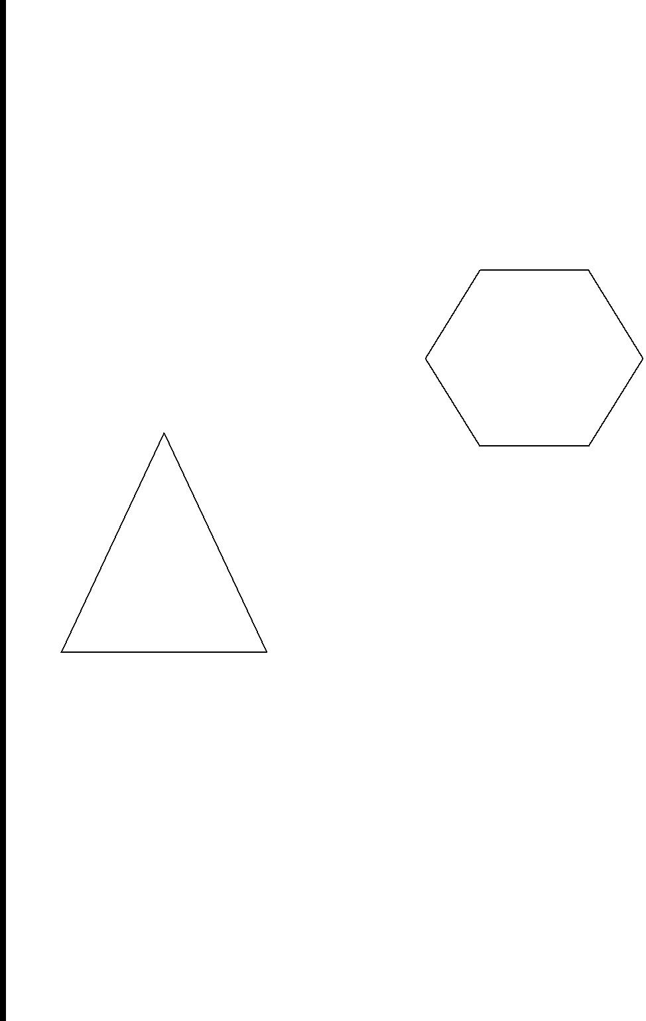

5 m

6m

|  |  |
| --- | --- |
| **2. Answer the following:** | 5m |

1.Find the boundary around a square field of 13m and 65 cm.

2.Find the distance around a rectangular table of length 50 cm and width of 20m.

3. Find the length of the barbed wire required to go around 4 times a rectangular field 63m and width of 35 m.

**Teacher’s sign.** **Parents’ sign.**

56

**WORK SHEET NO. 4** Date__________

Month_________

**Competency : Problem Solving Ability**

**1.** **A square garden is 200m long. How much wire will be needed for fencing around is 3 times?**

1. **Shika bought a roll of lace of 20m. She stitches it around 5 rectangular table clothes of length 1m 5 cm and breadth of 75 cm. What length of the lace will be left?**
2. **X runs a circular play ground of length 103m and 55cm anf Y runs a play ground of length 97m and 85cm. What is difference in distance?**
3. **Ram walks around a square field of length 6m and 25cm and Tanish walk around a rectangular field of length 4m 80cm and breadth of**

**5m10 cm.** **Who walks a greater distance and by how much?**

**Teacher’s sign.** **Parents’ sign.**

57

|  |  |
| --- | --- |
| **Topic: Smart Charts** | Date__________ |
| **WORK SHEET No. 1** | Month__________ |

**Competency :-Understanding Basic Concepts**

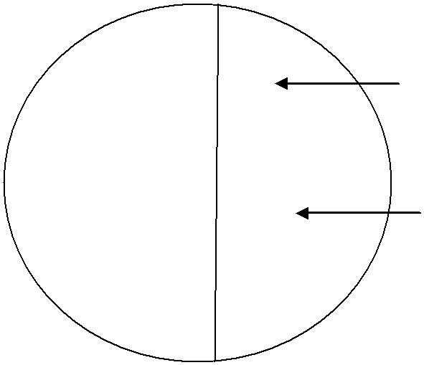

|  |  |  |  |
| --- | --- | --- | --- |
| Those who |  | Those who like Ice-Cream |  |
| Like |  |  |  |
| Milk |  | Those who like juice |  |
|  |  |
| shake |  |  |  |

**See the Chapati chart and answer the questions given below:**

a) How many children like Ice cream?

(i) One – third (ii) One – fourth (iii) Three- fourth

b) How many like Milk Shake?

i) One – third (ii) Half (iii) One fourth

c) Which item are liked by equal number?

(i) Milk shake and Juice (ii) Milk shake and Ice cream

* 1. Ice- cream and Juic

1. If total numbers of children are 405 then tell the number of children like: Ice – cream (ii) Milk shake (iii) Juice

**Teacher’s sign.** **Parents’ sign.**

58

**WORK SHEET NO. 2** Date__________

Month_________

**Competency : Ability to Compute**

There are 160 people in an apartment. The different newspaper they read is represented in this chapatti chart:

Observe the chart and write

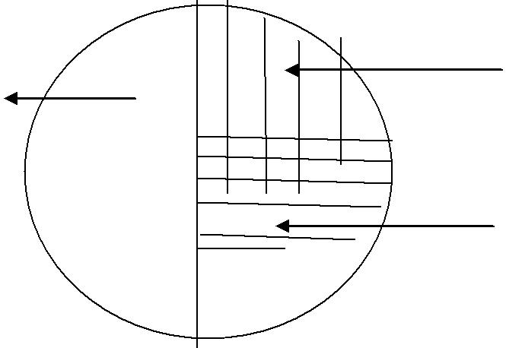

|  |  |
| --- | --- |
| Deccan | The Hindu |
| Herald |  |
|  | Times of India |

* 1. Which newspaper is read the most? ____________________________
  2. Which newspaper is read the least?_____________________________
  3. Find the total number of newspapers read by all? __________________

1. Observe this chart and answer. 1 = 4 children

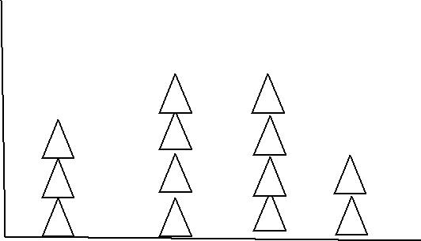

|  |  |  |  |  |
| --- | --- | --- | --- | --- |
| a) | Number of children who like red colour = _________ |  |  |  |
| b) Number of children who like blue colour: _________ | | Red | BlueYellow green |  |
|  |  |  |
| c) | Total number of students: ____________ |  |  |  |

**Teacher’s sign** **Parents sign**

59

**WORK SHEET NO. 3** Date__________

Month_________

**Competency : Ability to Compute**

**1.** **Number of balls sold by a shop on 6 days of a week. : Monday 17, Tuesday 12, Wednesday 20, Thursday 15, Friday 5 and Saturday 11.**

1. How m any balls were sold on all the 6 days?
2. On which day the balls were sold more?
3. On which day less number of balls were sold?
4. How many balls were sold on Saturday than Friday ?
5. Number of balls sold on Thursday is thrice the number sold on Friday True/False

**Teacher’s sign.** **Parents’ sign.**

60

**WORK SHEET NO. 4** Date__________

Month_________

**Competency : Ability to Compute**

1. **The Number of loaves of bread baked in a bakery in four different months of a year are given below. Each picture represents 100 loaves.**

|  |  |  |  |  |  |  |  |  |  |  |  |  |  |  |  |  |  |  |
| --- | --- | --- | --- | --- | --- | --- | --- | --- | --- | --- | --- | --- | --- | --- | --- | --- | --- | --- |
| January | : |  |  |  | BREAD | | |  |  | BREAD | |  |  | BREAD |  |  |  |  |
| February | : |  |  |  |  |  |  |  |  |  |  |  |  |  |  |  |  |  |
|  |  |  |  |  |  |  |  |  |  |  |  |  |  |  |  |  |
|  |  |  | BREAD | |  |  |  | BREAD |  |  |  | BREAD |  |  | BREAD |  |
| March |  | : |  |  |  |  |  |  |  |  |  |  |  |  |  |  |  |  |
|  |  |  |  |  | |  |  |  | |  |  |  |  |  |  |  |
|  |  |  | BREAD |  |  |  |  | BREAD |  |  |  | BREAD |  |  |  |  |
|  |  |  |  |  |  |  |  |  |  |  |  |  |  |  |  |  |  |  |

|  |  |  |  |  |
| --- | --- | --- | --- | --- |
| April : | BREAD |  | BREAD |  |
|  |  |  |  |
|  |  |  |  |  |

**Answer the following questions:**

1. Name the months in which the number of loaves baked was the same?
2. How many loaves were baked in January ?
3. In which month the number of loaves baked was minimum ?
4. What is the number of loaves baked in all the four months?
5. How many loaves were baked in March ?

**Teacher’s sign.** **Parents’ sign**

61